ECHO MEANS BUSINESS (EMB)

Functional Specification

# Contents

[ECHO MEANS BUSINESS (EMB) 1](#_Toc57662797)

[Contents 2](#_Toc57662798)

[1 Overview 4](#_Toc57662799)

[1.1 Next version 4](#_Toc57662800)

[1.2 Gamification 6](#_Toc57662801)

[1.3 To Do List 6](#_Toc57662802)

[1.4 Scope of Work 7](#_Toc57662803)

[1.5 Timelines 8](#_Toc57662804)

[1.5.1 Phase 1 8](#_Toc57662805)

[1.5.2 Phase 2 10](#_Toc57662806)

[1.5.3 Phase 3 11](#_Toc57662807)

[1.6 Testing Requirements 12](#_Toc57662808)

[2 Screen by screen specification 13](#_Toc57662809)

[2.1 Template ‘Main’ 13](#_Toc57662810)

[2.1.1 [NEXT VERSION: Control Mission] 17](#_Toc57662811)

[2.2 Page ‘Home’ 18](#_Toc57662812)

[2.3 Register / Log In /Profile 29](#_Toc57662813)

[2.3.1 Page ‘Log In’ 30](#_Toc57662814)

[2.3.1.1 Page ‘Forgot Password’ 31](#_Toc57662815)

[2.3.1.2 ‘Log In’ via Google 32](#_Toc57662816)

[2.3.1.3 ‘Log In’ via Facebook 33](#_Toc57662817)

[2.3.2 Page ‘Join’ 33](#_Toc57662818)

[2.3.2.1 Register via Facebook 38](#_Toc57662819)

[2.3.2.2 Register via Google 39](#_Toc57662820)

[2.3.3 Page ‘User Profile’ 41](#_Toc57662821)

[2.3.3.1 Profile Completeness 45](#_Toc57662822)

[2.4 Page ‘Pro Tips’ 45](#_Toc57662823)

[2.4.1 Page ‘Pro Tips – Details‘ 50](#_Toc57662824)

[2.4.2 Page ‘Pro Tips by Category’ 55](#_Toc57662825)

[2.5 Page ‘Pro Forum’ 57](#_Toc57662826)

[2.5.1 Page ‘Pro Forum – Details’ 60](#_Toc57662827)

[2.6 Page ‘Pro Rewards’ 60](#_Toc57662828)

[2.6.1 Page ‘Pro Reward - Details’ 63](#_Toc57662829)

[2.6.1.1 Popup ‘How to Redeem’ 67](#_Toc57662830)

[2.7 Page ‘Pro Workshops’ 68](#_Toc57662831)

[2.8 Page ‘Pro Networking’ 76](#_Toc57662832)

[2.8.1 Page ‘Pro Networking - Details’ 80](#_Toc57662833)

[2.8.1.1 Popup ‘Add to Your Calendar’ 89](#_Toc57662834)

[2.9 Page ‘Pro Missions’ 90](#_Toc57662835)

[2.9.1 Details page 92](#_Toc57662836)

[2.10 Page ‘Membership’ 95](#_Toc57662837)

[2.11 Page ‘Leaderboard’ 95](#_Toc57662838)

[2.11.1 Page ‘Points and Badges’ 98](#_Toc57662839)

[2.12 Page ‘Become a Member’ 101](#_Toc57662840)

[2.13 Page ‘Contributors’ 105](#_Toc57662841)

[2.14 Page ‘UAG Members’ 107](#_Toc57662842)

[2.15 Page ‘Meet the Pros’ 111](#_Toc57662843)

[2.15.1 Public User – Gateway (please login pop-up) 114](#_Toc57662844)

[2.15.2 Public, Basic & Pro User 115](#_Toc57662845)

[2.16 Pages ‘About Us’, ‘Privacy Policy’, ‘Terms’, ‘Community Rules’, ‘FAQ’ 116](#_Toc57662846)

[2.17 Page ‘Get Mobile App’ 118](#_Toc57662847)

[2.18 Page ‘Membership Pricing’ 121](#_Toc57662848)

[2.18.1 Page ‘Membership Subscriptions’ 121](#_Toc57662849)

[3 Administrative Interface 122](#_Toc57662850)

[3.1 Page ‘EMB Settings’ 122](#_Toc57662851)

[3.2 Users 122](#_Toc57662852)

[3.3 Pro Tips 123](#_Toc57662853)

[3.4 Offers 124](#_Toc57662854)

[3.5 Content Blocks 125](#_Toc57662855)

[3.6 Events 126](#_Toc57662856)

[3.7 Offers 127](#_Toc57662857)

[4 Appendix 130](#_Toc57662858)

[4.1 General Website Sections 130](#_Toc57662859)

[4.1.1 Section ‘Leaderboard’ 130](#_Toc57662860)

[4.1.2 Section ‘Get to Know Pro Members’ 131](#_Toc57662861)

[4.1.3 Section ‘Pro Members You May Know’ 132](#_Toc57662862)

[4.1.4 Section ‘Listen to the EMB Podcast’ 133](#_Toc57662863)

[4.1.5 Section ‘Pro Tips’ 133](#_Toc57662864)

[4.1.6 Section ‘Pro Forum’ 135](#_Toc57662865)

[4.1.7 Section ‘Pro Rewards’ 135](#_Toc57662866)

[4.1.8 Section ‘Pro Workshops’ 136](#_Toc57662867)

[4.1.9 Section ‘Pro Networking‘ 136](#_Toc57662868)

[4.1.10 Section ‘UAG‘ 137](#_Toc57662869)

[4.1.11 Section ‘Check These Out’ 137](#_Toc57662870)

[4.2 Membership / User Roles 139](#_Toc57662871)

[4.2.1 Membership plugins 140](#_Toc57662872)

[4.3 Secure dialog for Admin 140](#_Toc57662873)

[4.3.1 Search Results 141](#_Toc57662874)

[4.4 Video Hosting Service 142](#_Toc57662875)

[4.5 Set/Reset Like Status 142](#_Toc57662876)

[4.6 Date/Time format for Comments 143](#_Toc57662877)

[4.7 List of Comments 143](#_Toc57662878)

[4.8 Points 144](#_Toc57662879)

[4.9 Badges 148](#_Toc57662880)

[4.10 UltimateMember Settings 150](#_Toc57662881)

[4.10.1 Email 151](#_Toc57662882)

[4.10.2 Registration Form 151](#_Toc57662883)

[4.10.3 User Roles 152](#_Toc57662884)

[4.10.4 Account Tab 153](#_Toc57662885)

# Overview

Creative mockups for presentation:

<https://drive.google.com/open?id=1aw6fNtgSxL5gi0z0nMfM3SZ5zGB9joeS&authuser=angelina%40senseimarketing.com&usp=drive_fs>

[Oct 5, 2020] Robert’s notes:

<https://docs.google.com/spreadsheets/d/1nBFBaD2FtEHmWyJ3Zm5aMI1fgdKMMPkUK4o4SHdR69E/edit#gid=1600543433>

[Nov 30, 2020] Google doc with Points, Badges and so on

<https://docs.google.com/spreadsheets/d/1nBFBaD2FtEHmWyJ3Zm5aMI1fgdKMMPkUK4o4SHdR69E/edit#gid=0>

[Jun 3, 2020]

|  |
| --- |
| Responsibilities:   * Sam/Laura: creative * Me: spec / development   Other considerations:   * Use new Bondai WP platform * Only Sensei will have access to Admin interface * Mobile creative – no changes, only add new features   [Open Issue to Sam: what payment gateway will be used for ECHO?]  [PM: need to code purchases from mobile – Membership subscription] |

## Next version

|  |  |
| --- | --- |
| **Feature** | **Details** |
| Forum | [Jun 10, 2020 from Sam]  Robert and I have reviewed the functionality you shared for the new forum you have included in BONDAI. I think it can work; however, we'll likely ask you about:   * Updating the creative/style guide [SP: should be part of the current version] * Can we send alerts through the mobile app when someone subscribes to the forum discussion and leaves a response? [SP: this requires extra time and writing spec] |
| monthly newsletter for EMB that’s just to highlight community conversations | [Sept 14, 2020 from Sam]  Take a look at the Asana email below. It’s a recap of the popular conversations.  Wondering if we should consider a monthly or bi-monthly newsletter for EMB that’s just to highlight community conversations?  So we may wish to consider two emails in EMB 2.0. One monthly newsletter that we create each month and an automated recap email like the one below? Just putting the idea out to there |
| Recommended plugins from Robert | [PM: review this below from Robert]  Check out:  - www.convertkit.com (http://www.convertkit.com)  - https://flyplugins.com/wp-courseware/ (for Pro School). |

## Gamification

[Jun 29, 2020 from a call]

[PM: review these notes below]

Notes from today's chat, re: Gamification. Please create a thread to update anything else that I may have missed.

* Points: Points should be equal for all members, Basic (free, subscribed) and Pro (paid, subscribed); public users cannot earn points. Paid members can be incentivized in other manners, such as the award of badges, etc. that allows for a 2nd level of rewards.   Remember, while we may have 1K -3K in paid members, there's an opportunity to engage tens of thousands of non-paid members and so we cannot dis-incentivize them.
* Badges: Badges can be earned by the achieving certain point levels (E.g. 1000, 5,000, etc.) during a time period (monthly or yearly) - and - badges can be earned by completing specific tasks such as: Top X of the month, or completing specific tasks (or combination of tasks) such as "Networker" badge for participating in 3 networking events, a "Mentor" badge for replying to 50 questions in the forum, or a "Contributor" badge for submitting 3 videos/articles in a quarter for the Pro-Tips section. We also have UAG and UAG Council badges given to members in the year they're nominated to the board.
* Mission of the Week (MOW): MOWs will be synced with current "Weekly Challenges" available on the mobile app so we only have one program. MOWs will earn extra points for completion and possibly earn "Most Engaged" Badge for completion of X challenges.
* Marketing Emails: We'll continue with monthly newsletters for the launch of the program, possibly with personalized content based on the user's points, next level opportunities, etc. Plan for future launch of additional marketing emails.

Action Items:

* Robert to complete a list of the all
* Badge names/actions to be developed and designed, all to contribute
* Plan/document email campaign

## To Do List

|  |  |
| --- | --- |
| **Item** | **Details** |
| New creative |  |
| Forum | Apply for:   * Web Site * Mobile |
| Membership subscription | Apply for:   * Web Site * Mobile |
| Pro Tips | Apply for:   * Web Site [Jun 12, 2020 from call Sam] Use existing functionality from MSSB: tags, labels, categories, related section; * Mobile |
| Pro Rewards | Apply for:   * Web Site [Jun 12, 2020 from call Sam] Use existing functionality from MSSB: tags, labels, categories, related section; * Mobile |
| Pro School | Apply for:   * Web Site * Mobile   [PM: make research what of existing software can be used for school. First need to get detailed description of features] |
| Pro Networking | Apply for:   * Web Site * Mobile |
| Move LIVE content | * Forum topics and replies   + [Tech Note: IMPORTANT: do not move topics and replies which do not have users. If topic or reply does not have a user, then it means that this user was removed as SPAMMER] * Users   + Their properties   + User points * Articles and mobile posts * Challenges and responses * Mobile Posts |
| Mobile app | Apply all API and develop admin sections   * Feed * Posts * Articles * Challenges * Scores * Notifications * Menu:   + User profile     - Personal Information     - Email Address     - Business Address     - Password     - Profile Picture     - Notifications   + About Us   + EMB and UAG FAQs   + Privacy Policy   + Terms and Conditions   + Community Rules   + Became a UAG Member   + Contributors   + Log Out |
| Challenges | Develop Challenges (which are used on mobile now, but allow to use them on web as well) |
| Posts | Develop Posts (which are used on mobile now, but allow to user on web as well) |
| Feed | Develop Feed (which is used on mobile now, but allow to use it on web as well) |
| Email system | 1. Phase 1 – use SendGrid for mailcasts and for transactional emails 2. Phase 2 – use own system |
| LIKE for offers and Articles | [Jun 12, 2020 from call Sam, Robert, Angelina]  Add LIKE feature for offers and articles. Possible in NEXT version |

## Scope of Work

1. **BASE: DEVELOP A TIERED MEMBERSHIP PROGRAM**

Work/Service to Be Performed

1. **Upgrade the website and mobile app’s design** and application to allow for a tiered membership program where content and featured benefits will be made available to different groups based on their membership level.
2. **Develop a gamification strategy and user experience** that would encourage movement from the lowest tier to the highest tier and downloading of the mobile app or subscribing to emails and other features, during every engagement;
3. **Integrate an e-commerce component** that would allow members to purchase top tier membership or pay for digital or live events hosted by ECHO Means Business.
4. **Referral Program** - With the upgrading of ECHO Means Business to a tiered paid membership, Sensei recommends the introduction of a referral program for UAG or other members who recommend their fellow pros to enroll in the Pro Tier.
5. **E-commerce Management** 
   1. Pro tier members will be charged a suggested $95/year for access to this program, with a special introductory price of $39.99/year (example) for the first year through an integrated e-commerce platform.
   2. Note e-commerce transacts on the EMB website and no inventory needs to be purchased, warehoused, or shipped to fulfil this feature (unless ECHO products are included). All transactions occur on the website of participating vendors
6. **BASE: GENERAL SITE & ENGAGEMENT IMPROVEMENTS**

Work/Service to Be Performed

1. **Update the website forum design/tech** to improve user experience/ease of use
2. **Update creative design, navigation and layout** to:
   1. Accommodate new functions
   2. Improve gamification of website (motivating users to upgrade tiers and usage across all pages/functions)
   3. Increase subscriptions and gather more user feedback/preferences
3. **Search Engine Optimization Updates**
4. **Targeted Email Marketing Campaign** 
   1. Drip marketing for those who: Have subscribed but not registered; have subscribed to base membership to encourage paid memberships; have registered for paid tier requesting referrals and testimonial

## Timelines

Source <https://app.asana.com/0/607038627868623/1199155964593983>

### Phase 1

Planned due date:

* From Sam: Jan 18
* SP>I recommend to have at least **End of Jan-Mid Feb** to complete features below, because a lot of days in these months are holidays

|  |  |
| --- | --- |
| **Feature** | **Details** |
| New creative | Apply new creative for the website |
| New Forum | Apply new forum style for new website |
| Articles | Included:   * Manage articles, categories and tags * Comments * Share   Not included:   * Likes * Replies * Restricted content |
| Badges | NOTE: possible some badges rules cannot be implemented in this phase, in case if it is too complicated or depends on not implemented features.  AK: How about points /badges for this at the end of  Feb?  [PM: check new rules for badges] |
| Leaderboard | Points (Monthly and Yearly Leaderboard as we have it now)  NOTE: possible some badges rules cannot be implemented in this phase, in case if it is too complicated or depends on not implemented features.  [PM: review anew rules. Maybe not all rues can be applied in this phase]  Not included:   * Mentor tab |
| Profile | The same as on CPA + Chat + Friends |
| Membership | Included:   * Only: Public and Basic users * Pro Users BETA – only manually added PRO-Members will have access to   Not included:   * No payments * No change / cancel membership |
| Offers / Redemptions | Included:   * Manage offers, categories and tags * Comments * Share * Redeem method – only via visit external website   Not included:   * Replies * Likes |
| Networking / Networking registration | Included   * Manage events * Just two actions: Going / Not Going. * Comments * Share * Restricted for roles   Not Includes:   * Likes * Replies |
| Workshop | Just promotional content – no actual videos or functionality available to any member at this time.  Sam: Comment: in this document under "Workshops" you list : Just promotional content – no actual videos or functionality available to any member at this time."  NOTE that "workshops" are "videos" that will be somewhere between 30 and 60 minutes. We need to host/stream them so that only PRO members can access them. I am open to hosting them on our own servers (media servers if needed) or 3rd party service (Vimeo?) as long as it meets our requirements for only PRO members to be able to see them on our site. [SP>we will use our hosting (as a quick and temp solution), Vimeo or CloudFare (as it was on CPA). I am checking what is the best one][PM>we will use our hosting (as a quick and temp solution), Vimeo or CloudFare (as it was on CPA). I am checking what is the best one] |
| Registration | NOTE: Regarding Membership, on this date public user should be able to register as a Basic member (like today) but using social sign in options.  There should be no option to upgrade to Paid Membership. We can maybe show something that says: “Coming soon” or something like that for marketing purposes by only invited / manually added members can log in as “pro-member” during this Beta period.  AK: Social sign-in is easier for users which will give us higher conversion.  [SF Also - we’ve learned that people do not register easily with email/password so we’re looking to promote easier way. They WILL be able to register with email/password but design is planned to ask for social sign in first and then option for sign in with email (in small letters) below.  If they sign in with email/password, we need them to confirm their password via email link.]  Included:   * existing standard registration workflow with email/pass or via social network   Not Included:   * Integration with Unbounce |
| View mode for Offers, Networking and Workshop. | Public and basic members can see “offers,” “networking,” and “Workshops” but not do anything with it. |
| Move content live | * Users * Articles * Forum |
| Switch mobile app on new system |  |
| Sending emails | Via 3rd party SendGrid system, which was used for CPA  Sam: @sergey - I thought that we had problems with this system? I remember (I think) you and Dennis saying you were not happy with it because it took longer than planned to do the same work?  Would this be for the drip marketing emails Robert was talking about, or for our regular monthly newsletters? If it’s the latter, should we not use the MailCast system already integrated?  [PM>we have some experience with SendGrid, but yes, we can consider Mailchimp. Not sure that mailchimp is better. In Send grid we do not have HTML limitations, but in MailChimp we can face some unexpected issues.] |

**Phase 1 if there is possible, otherwise Phase 2:**

|  |  |
| --- | --- |
| **Feature** | **Details** |
| Mission of the Week | [PM: most of this should be coded from scratch, no such plugins. So I would schedule it another phase]  [SF Let’s plan for phase one, even if we have to simplify it. The Missions are what will keep this program growing so I’d like to not move this to phase two if possible]  AK: As noted, this is similar to CPA’s challenges so you may be able to duplicate. See Points tab here for all challenges types. Let me know what is doable for phase 1 and we will create challenges accordingly. |
| Meet The Pros | [Open Issue: we can easily add Directory as it is in standard configuration, just customize and adjust view, sort and filters. But we may not be able to complete points and badges for it in this phase]  [SF I am OK moving the points for this to Phase 2 to make priority for other items] |
| Pro Tips | * Add likes * Add replies for comments * Add restricted content |

### Phase 2

Planned due date:

* From Sam: February 22nd to March 15th, 2021
* [PM: I recommend 4-6mo => May or June, so we have time for changes, and coding new features]

|  |  |
| --- | --- |
| **Feature** | **Details** |
| Leaderboard | Mentor points |
| Membership | 7-day trial offer to convert Basic members to paid Pro members |
| Email drip | Marketing campaign for conversion (Robert working on business rules)  [Open Issue to Angelina: This may requires a lot of work to code logic and emails, so probably it is better to include into Phase 3 not Phase2. If need to include into Phase 2, then let add an additional month for coding  <https://app.asana.com/0/607038627868623/1199209490925924> ]  [PM: describe this. Creative in Zeplin for emails for those who join TRIAL membership  ] |
| Points | AK question: How do we display points on all items to show users the number of points they  get?  Task: <https://app.asana.com/0/1178924434621079/1198951217657822/f> |
| Workshop | Adding actual content and functionality, because Phase 1 is just promotional content |
| Simplified social registration | Robert’s mockup  <https://app.asana.com/0/607038627868623/1199157344249763>  [Open Issue to Angelina: provide final creative] |

### Phase 3

Planned due date: TBD

|  |  |
| --- | --- |
| **Feature** | **Details** |
| Mobile App sync w/new functionality |  |
| Gallery | Reference: <https://app.asana.com/0/607038627868623/1198971378001209>  We can implement something similar to CPA:   * Upload BEFORE image * Upload AFTER image * Add content * Submit   Once submitted we can display these works in a gallery - the same way as it was on CPA with a possibility to share or even comment.  Maybe we can incorporate these works into user profile like 'Jobs'. In this case if someone opens user profile he/she can see all these submits related to this user this type of changes/integration into the existing user profile can be complicated  Please let me know if need to discuss the workflow.  **Estimate:** ~80hr for the whole team |
| Plugin ‘Friends’ | AK: can we change the text “friends” to “connections”?  [SP>Nov 30, we can try, but it takes time. So I moved this into Phase2 or 3] |
| Mission Control | For reference: <https://app.asana.com/0/1178924434621079/1198951217657822/f> |

## Testing Requirements

Do testing using recent version only:

|  |  |
| --- | --- |
| **Platform** | **Browsers** |
| Windows | * Chrome, * FireFox, * Edge |
| Mac | * Safari |
| iOS | * Safari, * Chrome |
| Android | * Chrome |

# Screen by screen specification

Where is required, use the following page title ‘*ECHO Means Business: <page name>*’.

[Open Issue: provide email template for all admin emails. Preferable text format, no buttons or images. Case: <https://app.asana.com/0/1178924434621079/1198994613010185> ]

## Template ‘Main’

This is template which will be applied for all pages.

This template may look like this (for illustration only)

|  |
| --- |
| **[User dependent page content]** |

Controls description:

|  |  |  |  |  |  |  |  |  |  |  |
| --- | --- | --- | --- | --- | --- | --- | --- | --- | --- | --- |
| **Header**   |  |  | | --- | --- | | **Membership** | **Description** | | Public | * - Logo. Link to [Home page](#_Page_‘Home’_1). It opens in the same tab; * - the same link as a logo; * - Textbox. Empty by default. Max with 300chars. It allows user to search specific information on the website. When the user clicks in the search box, the word that is put there to trigger users to input text (the word 'search' is used) should instantly disappear, so they do not have to delete the word manually before they can enter their search term. After user enters search word or phrase + Enter, he’s redirected to the page [Search Results](#_Search_Results).   [NEXT VERSION: to investigate plugins which allow user to see the tips while entering the search word or phrase. Probably, for the next version.]   * - Link to [Register page](#_Page_‘Join’). It opens in the same tab. * - Link to [Login page](#_Page_‘Log_In’_1). It opens in the same tab. | | Basic | * Such items like EMB logo, text ‘Green Industry Community – For Pros, By Pros, textbox ‘Search’ described above for Public user are the same for Basic user. * - User avatar. * **Sam** – User first name. Must be taken from **Users -> First Name.** When user clicks his first name, it shows:   + My Profile, it opens [‘User profile’ page](#_Page_‘User_profile’) in the same window;   + Logout, it closes user session and opens the [Home page](#_Page_‘Home’) in the same window.      * - friends request icon * - Icon. When user clicks, it shows the newest conversations and a text-link ‘**See all messages’,** which redirects user to **Profile -> Private messages.** [PM: It’s Ultimate Member plugin functionality. To investigate: how does it work.]  * - Icon. When user clicks, it shows the newest notifications and a text-link ‘**See all notifications’**,which redirects user to Notification page. * Membership:   + - Static text for [‘Basic’ membership](#_Membership_/_User); * Points:   + - Static icon and text.   + **54** – Total number of points for user. Must be taken from **Users -> Balances (Points).** | | Pro | * Such items like EMB logo, text ‘Green Industry Community – For Pros, By Pros, textbox ‘Search’, user avatar, user first name, ‘friends request’, ‘message’ icon, ‘notification’ icon, text ‘Membership’ and ‘Points’ described above are the same for Pro user. * - Static text for [Pro membership](#_Membership_/_User). | | Any other  (Admin for example) | Do not display ‘Membership’ section | |
| **Top menu**   |  | | --- | | * Pro Tips. Opens [Pro Tips page](#_Page_‘Home’) in the same window; * Pro Forum. Opens [Pro Forum page](#_Forum_1) in the same window; * Pro Workshops. Opens [Pro Workshops page](#_Page_‘Pro_Workshops’) in the same window; * Pro Rewards. Opens [Pro Rewards page](#_Pro_Reward_(Partner) in the same window; * Pro Networking. Opens [Pro Networking page](#_Page_‘Pro_School’) in the same window; * Pro Missions. Opens [Pro Missions page](#_Page_‘Pro_Missions’) in the same window; * UAG. Opens [UAG Members page](#_Page_‘UAG_Members’_1) in the same window; * **Pro Missions –** Link to [Pro Missions page](#_Pro_Missions). It opens in the same tab. * Other menu items are links as well, see the full description in Footer section. | |
| **Footer**   |  | | --- | | **Subscribe section**  It may look like this:    [Tech Note: use ‘Subscribe’ Gravity Forms and customize it according creative]  [Testing Notes: check that error validation will not break creative]  Controls description:   * Email address. Textbox, required;   Clicking ‘Subscribe’ does the following:   * Validates email address using standard Gravity Form validation procedures and displays error messages;   + Show pre-loader like here instead of Subscribe button (or similar):      * + Show errors like here:      * If validation passed successfully then:   1. Show a confirmation message instead of the form ‘*Thanks for signing up. Be on the lookout for our monthly newsletter!*’ [Tech Note: can be customized via plugin]. Example:      * 1. Saves email into the plugin DB; [Tech Note: this is part of plugin];      + This is OK to have duplicates, no need to validate them to avoid spammers to find submitted emails;   2. Send email to web admin [Tech Note: can be customized via plugin];      * 1. [NEXT VERSION: integrate Mailchimp or SendGrid Double Opt-in confirmation] | | * ‘ FOLLOW US’ - Static text. * – Link to <https://www.facebook.com/echomeansbusiness/>. It opens in the new tab. * - Link to <https://www.instagram.com/echo.meansbusiness/>. It opens in the new tab. * - Link to <https://www.youtube.com/channel/UC3_dtdhrJqS1thoH5WhK07Q>. It opens in the new tab. * ‘Watch EMB Video’ button - Popup video. This is HTML widget, which will include buttons and video popup, which should look like: * Title: Watch Echo Means Business video; * Button: 'Close' only; * Video: embed YouTube video.     [PM: temporary we will place the video: https://www.echomeansbusiness.com/client/user-advisory-group.jsf] | | NOTE: all the items for the sections below will be set up in **Appearance -> Widgets.**   * **Pro Tips –** link to open the same page as in top menu. * Links to article categories, e.g*.*, *‘Grow your Business’.* * Sort By [Nov, 03, 2020 from Angelina: It will be based on "most popular"]   [Tech Note: discussed with Sergey, Dima. We’re going to set it with **Appearance -> Widgets**].   * **Pro Forum -** link to open the same page as in top menu. * Links to forum categories/titles, e.g., ‘*Maintaining Outdoor Landscapes’*. * **Pro Workshops -** link to open the same page as in top menu. * Links to article categories. * **Pro Rewards -** link to open the same page as in top menu. * Links to rewards categories, e.g., *‘Entertainment’*. * **Pro Networking -** link to open the same page as in top menu. * **UAG -** link to open the same page as in top menu. * **Become UAG member** – Link to [Become a Member page](#_Page_‘Get_the). It opens in the same tab. * **Contributors** – Link to [Contributors page](#_Page_‘Contributors’) It opens in the same tab. * **Meet the Pros –** link to open the same page as in top menu. | | * **FAQ** - Link to [FAQ page](#_FAQ). It opens in the same tab. * **Privacy Policy** - Link to [Privacy Policy page](#_Pages_‘About_Us’,). It opens in the same tab. * **Terms and Conditions** - Link to [Terms and Conditions page](#_Pages_‘About_Us’,). It opens in the same tab. * **Community Rules** - Link to [Community Rules](#_Pages_‘About_Us’,) page. It opens in the same tab. | | * - Logo. Link to <https://www.echo-usa.com/>. It opens in a new tab. * - Static text. [Tech Note: Display [Current Year] instead of ‘2020’] | |

### [NEXT VERSION: Control Mission]

[PM: describe this]

Collapsed:

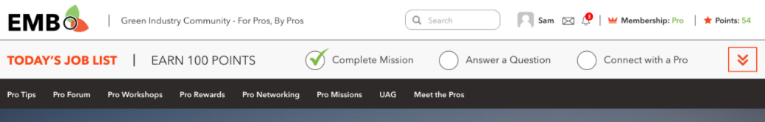

Expanded:

|  |
| --- |
|  |

## Page ‘Home’

Home page can look differently based on [user role/membership](#_Membership_/_User).

It may look like this (for illustration only), included into [Main Template](#_Template_‘Main’).

|  |
| --- |
|  |

Controls description:

|  |  |  |  |  |  |  |  |  |
| --- | --- | --- | --- | --- | --- | --- | --- | --- |
| **Top banner**  Top banner depends on [user role/membership](#_Membership_/_User). [Tech Note: use UM shortcode to show hide content which depends on user role]   |  |  | | --- | --- | | **Membership** | **Banner** | | Free | * Join Free - Link to [Register page](#_Page_‘Join’). It opens in the same tab. * ‘Watch Video’ – popup video. The same as for ‘[Watch EMB video’](#_Home_Page) button (footer). * All other is just static content | | Basic | [Note from Angelina Nov 19, 2020: hide two buttons for now]  [Open Issue to Angelina <https://app.asana.com/0/1178924434621079/1199231975176391>: what should be opened by ‘Go Pro’ and ‘Watch Video’ in Phase 1? Maybe hide them?]  [PM: describe membership page for ‘Go Pro’] | | Pro | Any content. Will be managed via admin panel – LiveCanvas. | |
| **Pro Members You May Know**  This section is described in the [chapter Appendix->’Pro Members You May Know’](#_Section_‘Pro_Members). |
| **Pro Tips**   |  | | --- | | - Static text | | - Static HTML block. Admin can adjust copy manually. [Tech Note: allow to manage it via LiveCanvas]; | | **Featured Pro Tip**  [Tech Note: this block should be automatically generated based on article. Options:  #1: Add a shortcode into HTML [Discussed with Dima, we’re going to add shortcode]  #2: Code a custom widgets to select article to be displayed in this place]  All block is clickable. It opens same as ‘Watch Video’ (or ‘View Pro Tip’).   * - Pro tip image. * - Pro tip category, if there are more than one category, then display the first one by ascending order. * - Pro tip title. * - Link to the page ‘[Pro Tip Details](#_Page_‘Home’)’. It opens in the same window. Link depends on pro tip type (Video or Article), and can be: * Watch video; * View pro tip. | | **Leaderboard**  It is described in details in the [section Appendix->‘Leaderboard’](#_Section_‘Get_to). | | **Listen to the EMB Podcast**  It is described in details in the [section Appendix->‘Listen to the EMB Podcast’](#_Section_‘Listen_to). | |
| **Pro Tips**  It is described in details in the [section Appendix->‘Pro Tips’](#_Section_‘Pro_Tips’). |
| **Pro Forum**  It is described in details in the [section Appendix->‘Pro Forum’](#_Section_‘Pro_Forum’).    [Tech Note: this is WPForum plugin] |
| [NEXT VERSION:  **Mission of the Week**   * Mission of the Week – Static text. * ‘Complete your Mission of the Week and Earn Points’ – Static text.   -   * ‘Mission of the Week’ button – Link to the [Pro Mission](#_Pro_Missions) page. It opens in the same tab.   ] |
| **Pro Rewards & Discounts**  It is described in details in the [section Appendix->‘Pro Rewards’](#_Section_‘Pro_Rewards’). |
| **Pro Workshops**  It is described in details in the [section Appendix->‘Pro Workshops’](#_Section_‘Pro_Workshops’). |
| **Pro Networking**  It is described in details in the [section Appendix->‘Pro Networking’](#_Section_‘Pro_Networking‘). |
| **UAG**  It is described in details in the [section Appendix->‘UAG’](#_Section_‘UAG‘). |

## Register / Log In /Profile

[PM: Nov 30, 2020 check and describe these emails. They do not look good and they are sent to users

* Also it includes WordPress inside

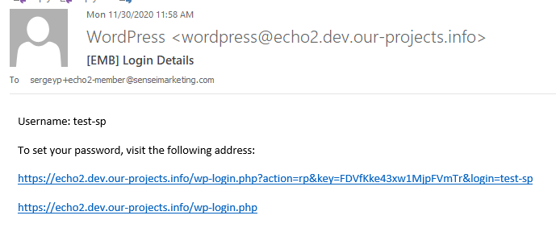

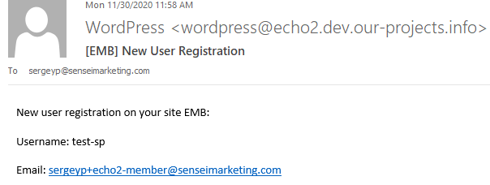]

### Page ‘Log In’

This is page to log in on the website.

This page may look like this:

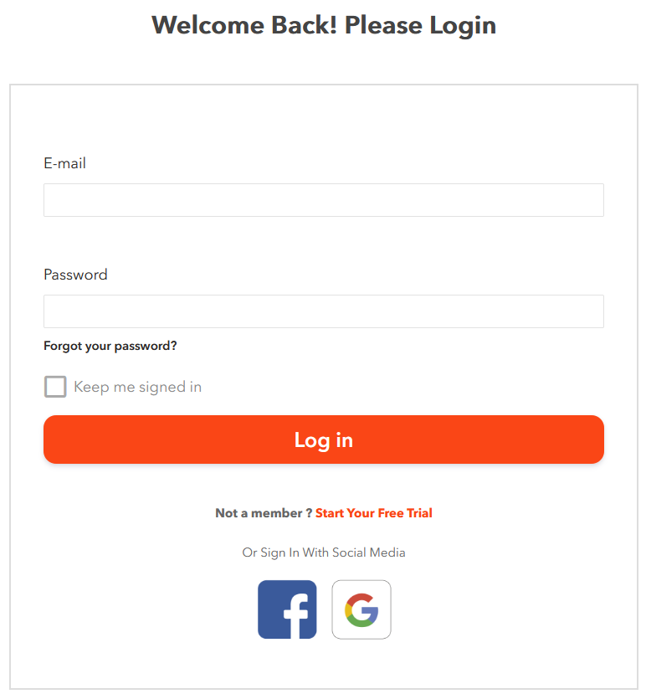

[Tech Note: this page is Ultimate Member plugin]

[PM: we won’t use ‘Sign In’ with LinkedIn so far. ‘Email or Username’ is renamed to ‘Email’]

Controls description:

* ‘Welcome back! Please login’, ‘Not a member?’ – Static text.
  + Email. Textbox. It allows user to enter his email address or username. Mandatory field. ~~Maximum 320 chars~~;
  + Password. Textbox. It allows users to enter his password. Mandatory field. ~~Maximum 30 chars~~.
* ‘Forgot Your Password?’. It follows standard existing WP rules. See [page ‘Forgot Password’](#_Page_‘Forgot_Password’) below;
* ‘Log In’ button. It follows standard existing WP rules.
* ‘Keep me signed in’. Checkmark. Unchecked by default.
* ‘Start Your FREE Trial.’ Link to [Register](#_Forgot_Password) form. It opens in the same window.
* [Sign In with FB](#_‘Log_In’_via). Enables to login with Facebook account, the website can access information user has added on Facebook.
* [Sign In with Google](#_‘Log_In’_via_1). Enables to login with Google account.

#### Page ‘Forgot Password’

This page is used when user clicks ‘Forgot your password?’.

This page may look like this:

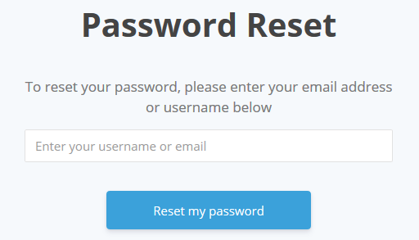

Clicking ‘Reset my password’ does standard validation and the following email is sent [Tech Note: email is configured in the Dashboard->Ultimate Member->Settings->Email->Password Reset Email]:

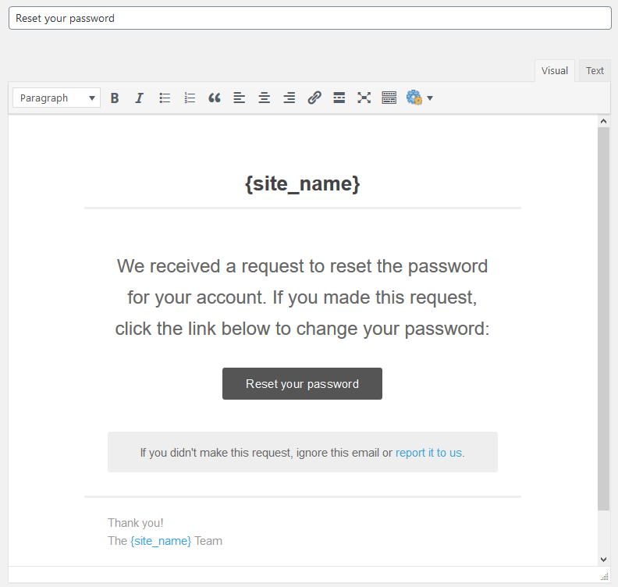

Where:

* ‘report it to us’ is email which is configured in the **Dashboard->Ultimate Member->Settings->Email->Admin Email Address**.

#### ‘Log In’ via Google

Steps how to log in via Google:

|  |  |
| --- | --- |
|  |  |

#### ‘Log In’ via Facebook

Step how to log in via Facebook:

|  |  |
| --- | --- |
|  |  |

### Page ‘Join’

[PM: describe this when a new user is added via admin panel

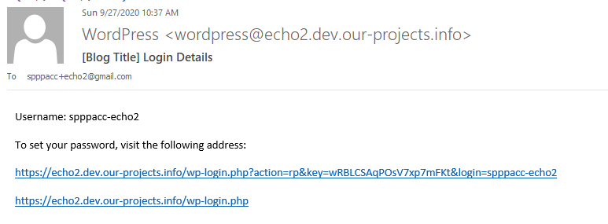

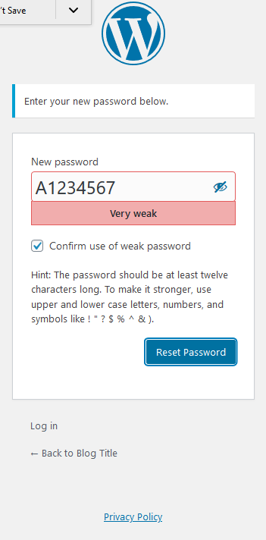

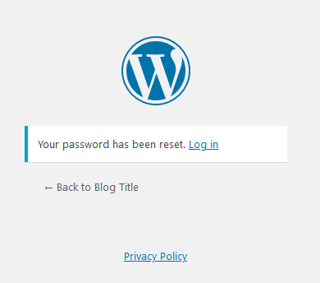

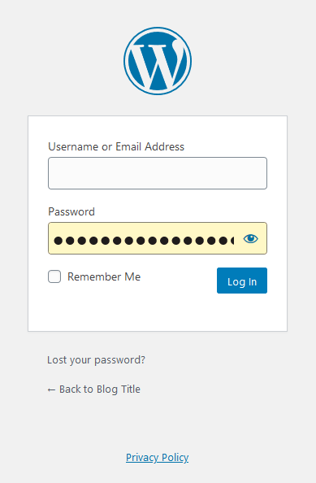

This is page to register on the website.

[Tech Note: registration should be done via email confirmation link]

This page may look like this (for illustration only):

[Open Issue: please provide creative]

|  |
| --- |
| **Join**  First Name  [\_\_\_\_\_\_\_\_\_\_\_\_\_\_\_\_\_\_\_\_\_]  Last Name  [\_\_\_\_\_\_\_\_\_\_\_\_\_\_\_\_\_\_\_\_\_]  E-mail Address  [\_\_\_\_\_\_\_\_\_\_\_\_\_\_\_\_\_\_\_\_\_]  [ ] Subscribe to Monthly Pro-Users newsletter  By clicking "Submit", I agree that:   * I have read and accept the [Terms & Conditions](https://www.echomeansbusiness.com/client/terms.jsf) and the [Community Rules](https://www.echomeansbusiness.com/client/community-rules.jsf). * I may receive communications from ECHO Means Business and can change my notification preferences in the User Profile section of the website at any time.   [Register] [Login] |

This is example from the existing website (for reference only)

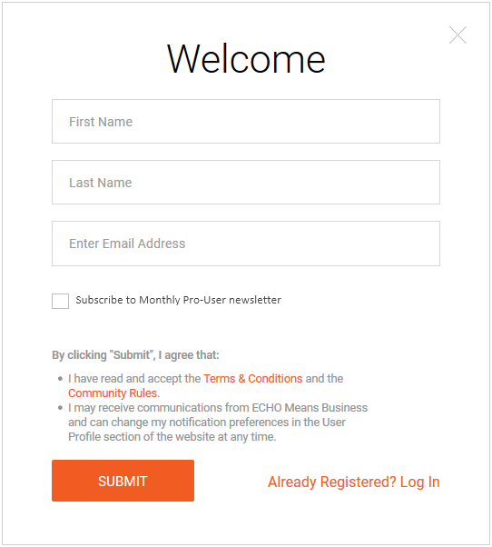

Controls description

* First Name, Last Name and Email are mandatory;
* ‘Subscribe ..’ checkmark is optional.

Links:

* Terms & Conditions. Opens this page in the same window;
* Community Rules. Opens this page ion the same window.

Clicking ‘Login’ opens [‘Log In’ page](#_Page_‘Log_In’) in the same window.

Clicking ‘SUBMIT’ does the following:

* Fields validation,
* Send email to activate account.
  + Email configuration in **Dashboard->Ultimate Member->Settings->Email->Account Activation Email**.

(Font: Courier New, Size: 10 points)

|  |  |
| --- | --- |
| FROM | <website name> <no-reply@echomeansbusiness.com> |
| TO | <user first and last name> <user’s e-mail> |
| SUBJECT | ECHOMeansBusiness.com Registration Confirmation |
| BODY | Hello <first name>,   Someone with this email has registered a user profile at <www.echomeansbusiness.com>, the premier community and information hub for and by professional users of outdoor power equipment.    If this was you, for security purposes, we need you to confirm your request and user profile. Please click the following link to confirm your registration request: <activation URL>  NOTE: Once you’ve logged in, you can edit your profile name by hovering over your name at the top right of the website and then clicking: “user profile.”  If you didn't request creating an account, just ignore this mail.  Thank you,  ECHO Means Business  <https://www.echomeansbusiness.com> |

* + - Fields in yellow are variables
      * <activation URL> this is link to activate account.
* Shows a message with steps to activate account

|  |
| --- |
| IMPORTANT MESSAGE  Thank you for registering. Before you can login we need you to activate your account by clicking the activation link in the email we just sent you.  **If you don't see the e-mail message in your inbox, look for it in your junk or spam mail folder or check your e-mail again later.** |

Once user activates account then:

* The following page opens:

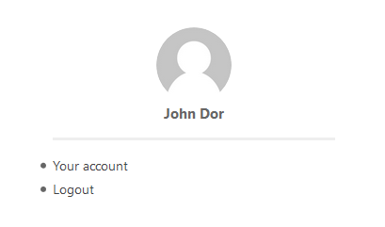

* Confirmation email is sent:
  + Email configuration in **Dashboard->Ultimate Member->Settings->Email->Account Welcome Email**.

(Font: Courier New, Size: 10 points)

|  |  |
| --- | --- |
| FROM | <website name> <no-reply@echomeansbusiness.com> |
| TO | <user first and last name> <user’s e-mail> |
| SUBJECT | Welcome to the ECHOMeansBusiness Pro Community |
| BODY | Hello, <first name>.  Thank you for confirming your registration request and welcome to the ECHOMeansBusiness.com community for and by pro users of outdoor power equipment.  A few tips and reminders:  1. The community is open to all professional users of outdoor power equipment regardless of their employment status (business owner or operator), favorite brands, or type of business (landscape, lawn care, arbor, or grounds maintenance crew).  2. The community is led by a group of volunteer professionals known as the User Advisory Group (UAG) who share their personal and professional experiences with the wider community through blogs, videos, and other on-site and at-event promotions. See this year’s members here: <link to UAG member page>.  3. Multiple times a week, community members post business and pro-user articles and tips on the site so check back frequently for the latest news and updates from the pros.  4. Got a question for other pros in the community? Join the forum today. It’s a busy hub for questions and answers. Check it out today: <link to forum>.  5. The more you engage, the more points you earn! Visiting, reading, watching, and sharing information within the community earns each logged in member points, which moves him or her up the leaderboard. The more you engage, the higher up the leaderboard you go! If you don’t want your professional name to appear on the leaderboard, be sure to visit the “My Profile” section once logged in to update your user name.  The community looks forward to your engagement.  Have a great day!  The ECHOMeansBusiness team. |

* + - Where yellow fields are variables:
      * <link to UAG member page> opens [page ‘UAG Members’](#_Page_‘UAG_Members’);
      * <link to forum> opens [page ‘Forum’](#_Forum_1).

#### Register via Facebook

[Open Issue: Dima – cannot register via FB. Why?]

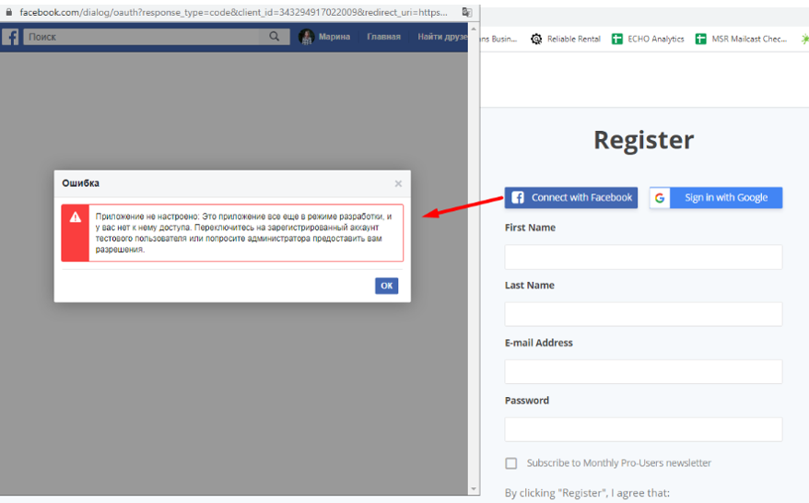

#### Register via Google

Registration via Google includes the following steps:

|  |  |
| --- | --- |
|  | |
| * "privacy policy" - <https://echo2.dev.our-projects.info/privacy-policy/> * "terms of service" - <https://echo2.dev.our-projects.info/terms-conditions/> | [Open Issue: Dima – remove Username] |
| [Open Issue: Dima – add space between paragraphs] |  |
|  |  |

### Page ‘User Profile’

Requirements:

* Features:
  + Hide/deactivate the following features:
    - **Messages**, **Reviews**, **Bookmarks**, **Private Content**, Member directory, **Tags**, **Verified User**, **Groups, Posts, Comments**
  + Leave active:
    - Comments [Nov 19, 2020 users can leave comments for Pro Tips];
    - About
    - Activity
    - Badges
    - Forums
    - [Note Nov 19, 2020: These plugins below were installed by Sam request]
    - Friends
    - Followers
    - Following
    - Private Messages
* Profile Fields

|  |  |  |  |
| --- | --- | --- | --- |
| **Name** | **Required** | **Privacy / Visibility** | **Type** |
| Business Name | Yes | Only visible to profile owners and admins /  View everywhere (edit and view mode) | Text, 100 chars |
| **Business Address** |  |  |  |
| Country | Yes | -//- | Drop-down with list of countries sorted by name in ascending order |
| Address Line 1 | Yes | -//- | Textbox, 100 chars |
| Address Line 2 | No | -//- | Textbox, 100 chars |
| City | Yes | -//- | Textbox, 100 chars |
| State / Province | No | -//- | Logic and fields:   * If **Canada** was selected, then:   + Drop-down with a list of provinces * If **USA** was selected, then:   + Drop-down with a list of states * Otherwise:   + ‘(no state / province)’.   Items in the drop-downs should be sorted in ascending order by name.  [Tech Note: utilize Edit Field->Choices Callback to return list of choices. Do not use conditional logic, because it will not work in Profile Completeness. Profile Completeness does not support conditional logic] |
| ZIP / Postal Code | Yes | -//- | Textbox, 20 chars |
| **Occupation** |  |  |  |
| Employment Status | No | -//- | Drop-down, values:   * Default - empty * Owner * Employee |
| Type of Business | No | -//- | Drop-down, values:   * Default - empty * Lawn Service, * Landscape Contractor, * Arborist, * Tree Services, * Commercial Property Maintenance, * Golf Course, * Park Services, * Municipality, * Government Facility Maintenance, * School/Church/Cemetery, * Resort, * Other. |
| Number of Employees | No | -//- | Drop-down, values:   * Default - empty * <4, * 5-10, * 10-25, * >25 |

Example from existing website:

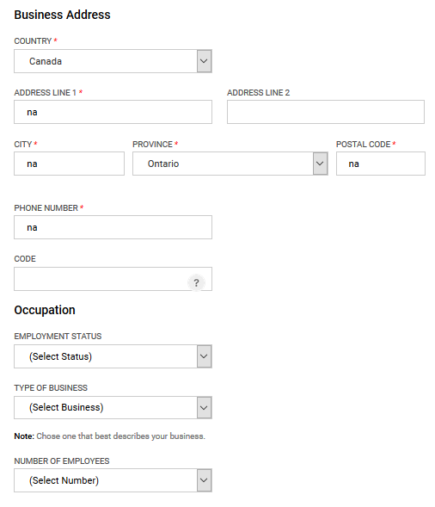

[Nov 10, 2020]

**The changes for User Profile are below:**

* NOTE: do not change button size, style, shape and font.

|  |  |
| --- | --- |
| Background color | * Change background color to #ededed |
| Complete your profile section | Place this block on the bottom right side of the page as shown on the mockup in Zeplin.   * Line: Change color to #7eb945. * Percent and completeness criteria: Change font color to #fa4616. |
| Buttons | * Update Profile button: Change color to #fa4616. The text is #fff. * Cancel button: Change color for the border and the text to #fa4616.   + When user hovers a mouse over this button, make it light-grey or light-orange.     **Important**: do not change button size, shape and font. |
| Messages | * Popup messages: Change color to #fa4616. The text is #fff. * Sens Message button: Change color to #fa4616. The text is #fff. * Border: Change color to #fa4616.      * Username: Change color to #7eb945. |

#### Profile Completeness

Include all fields from [Profile Fields] above into this feature.

* Give 10% for each field.

## Page ‘Pro Tips’

[PM: Nov 19, 2020: to me – describe points for Pro Tips – for comments, share and replies]

This is how this page looks like for all users.

It uses fields from a custom post [Pro Tips](#_EMB_Settings).

It may look like this (for illustration only), included into [Main Template](#_Template_‘Main’).

|  |
| --- |
| **[Pro Forum]**  **[Pro Rewards]**  **[UAG]**  **[Banner]** |

Controls description

|  |
| --- |
| **Section ‘Pro Tips’**    It is the same as it is on the [Home page](#_Page_‘Home’_1).  [Dev Note to Dima: if this block will be displayed on many pages, maybe make sense to implement it as shortcode with an option to select a featured article] |
| Sections ‘Latest Pro Tips’, ‘Pro User Tips’ and ‘Pro Biz Tips’ are the same as described in the section ‘Pro Tips’ on the [Home page](#_Page_‘Home’_1). |
| [NEXT VERSION: **Most Popular Tips**] |
| **Section ‘Tips by Category or Keyword’**    This section includes list of all pro tips tags sorted in ASC order. [Tech Note: do NOT add categories here, only pro tips tags].  Do not display this section if no tags  Clicking any tag opens page [‘Pro Tips by Category’](#_Pro_Tips_By) for clicked tag in the same window. |
| Section ‘Pro Forum’, ‘Pro Rewards’ and UAG are the same as on the [Home page](#_Page_‘Home’_1). |
| Section ‘Banner’. Can be provided later and coded like simple HTML block on a page. It does not require any description. |

### Page ‘Pro Tips – Details‘

This page displays pro tip details.

It uses fields from a custom post [Pro Tips](#_EMB_Settings).

[Tech Note: see pro tips fields in the Administrative Interface->[Manage Pro Tips](#_Manage_Pro_Tips)]

[NEXT VERSION: make restricted copy of this page for Public users. See example in Zeplin

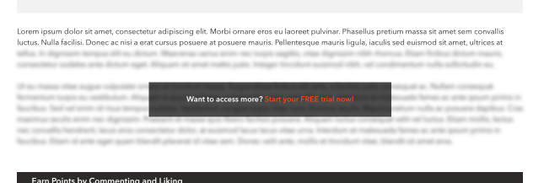

It may look like this (for illustration only), included into [Main Template](#_Template_‘Main’).

|  |
| --- |
| **[Leaderboard]**  **[Pro Rewards]**  **[UAG]**  **[Banner]** |

Controls description:

|  |
| --- |
| **Breadcrumb**    [NEXT VERSION: it is not correct in this creative. No need to display name and one article may have N categories] |
| **Pro Tip header**     * Pro tip title; * Author display name. **Custom Post->WP Author field**; * Published date in format: d mmm yyyy. Example: *3 October 2020.* |
| **Pro Tip details**  This is pro tip HTML content, which may include Text, HTML, Images and embed Video. |
| **Liking section**     * Like / Reset Like. See details in the chapter ‘[Set/Reset Like Status’](#_Set/Reset_Like_Status); * Button ‘Become a Contributor’ - opens the page [‘Become a Contributor’](#_Page_‘UAG_Members’) in the same window. |
| **Comments**  Adding comments:   * This section is controlled by WP and is available for logged in users only. So, WP should display something asking to log in to leave a comment     List of comments may look like this:    See full description in the chapter ‘[List of Comments](#_List_of_Comments)’. |
| **Email, Print and Share section**    [NEXT VERSION: Email and Print]   * + List of social networks [Tech Note: not logged in users can share];     - * [Tech Note: examples were taken from this website: <https://www.morganstanley.com/articles/a-veterans-career-transition-to-investment-banking> ];         + LinkedIn.  |  | | --- | | Example:  [**https://www.linkedin.com/shareArticle**?**mini**=true&**url**=https://www.morganstanley.com/articles/a-veterans-career-transition-to-investment-banking&**title**=A%20Veteran%E2%80%99s%20New%20Mission&**summary**=%22Learn%20how%20his%20military%20training%20prepared%20this%20Associate%20in%20our%20London%20office%20to%20take%20on%20the%20fast-paced%20world%20of%20Global%20Capital%20Markets.%22](https://www.linkedin.com/shareArticle?mini=true&url=https://www.morganstanley.com/articles/a-veterans-career-transition-to-investment-banking&title=A%20Veteran%E2%80%99s%20New%20Mission&summary=%22Learn%20how%20his%20military%20training%20prepared%20this%20Associate%20in%20our%20London%20office%20to%20take%20on%20the%20fast-paced%20world%20of%20Global%20Capital%20Markets.%22)  Parameters:   * mini. Always ‘true’; * url. Full path URL on this post; * title. [Post->Title] * summary. [Post->Content]   NOTE: cannot prefill text or pass hashtag |  * + - * + Twitter  |  | | --- | | Example:  [**https://twitter.com/share**?**url**=https://www.morganstanley.com/articles/a-veterans-career-transition-to-investment-banking&**text**=A%20Veteran%E2%80%99s%20New%20Mission](https://twitter.com/share?url=https://www.morganstanley.com/articles/a-veterans-career-transition-to-investment-banking&text=A%20Veteran%E2%80%99s%20New%20Mission)  Parameters:   * url. Full path URL on this post; * text. Pro tip title; |  * + - * + Facebook  |  | | --- | | Example:  [**https://www.facebook.com/sharer/sharer.php**?**u**=https://www.morganstanley.com/articles/a-veterans-career-transition-to-investment-banking](https://www.facebook.com/sharer/sharer.php?u=https://www.morganstanley.com/articles/a-veterans-career-transition-to-investment-banking)  Parameters:   * u. Full path URL on this pro tip;   NOTE: cannot prefill text or pass hashtag |  * + The following content should be shared.     - Metatags details:  |  | | --- | | <meta property="og:title" content="<pro tip title>"/>  <meta property="og:description" content="< pro tip excerpt (if empty then generate excerpt from WP) >"/>  <meta property="og:site\_name" content="<website name from Settings>"/>  <meta property="og:url" content="<full path URL on this pro tip>"/>  <meta property="og:image" content="<full path URL to [image]>"/>  <meta property="twitter:card" content="summary\_large\_image"/>  <meta property="twitter:title" content="<pro tip title>"/>  <meta property="twitter:image" content="<full path URL to [image] as for **og:image**>"/>  <meta property="twitter:description" content="<the same as for **og:description**>"/>  <meta property="twitter:url" content="<full path URL on this pro tip>"/>  <meta property="twitter:creator" content="Echo Means Business"/> | |
| **Tags**    Display list of tags linked with this pro tip.   * If not tags, then do not display label and section * Do not display tag which do not have other articles except this one; * Sort tags by ASC order.   Each tag is a link on the page [‘Pro Tips By Category’](#_Pro_Tips_By) in the same window. |
| **Related Pro Tips**  This section displays 3 pro tips by the following algorithm:   * Get list of this pro tip tags; * Get all pro tips with the same tags, excluding the current pro tip; * Sort these pro tips by published date in descending order. Most recent at the beginning; * Display first 3 pro tips.   This section should be hidden if there are no related pro tips.    Each pro tip has fields described on the [Home page](#_Page_‘Home’_1). |

### Page ‘Pro Tips by Category’

This page displays list of pro tips for particular category or tag.

It uses fields from a custom post [Pro Tips](#_EMB_Settings).

It may look like this (for illustration only), included into [Main Template](#_Template_‘Main’).

|  |
| --- |
|  |

Controls description:

|  |
| --- |
| **Top section**  - this section displays ‘category name’ or ‘tag name’ and ‘Tips’.  Example:   * Category is ‘*Pro Biz*’, then name will be ‘*Pro Biz Tips*’; * Tag is ‘*Tutorial*’, then name will be ‘*Tutorial Tips*’.   All words should start with a capital char, even if they all lower case. |
| **List of Pro Tips**   * Display all pro tips in the selected category or tags sorted by published date in descending order. Mote recent at the top * Standard pagination. 15 results per page, style “1,2,3 …” [PM: Discussed with Dima] |
| **Pro Tip**    It is the same as described for the slider on the [Home page](#_Page_‘Home’_1). |

## Page ‘Pro Forum’

[PM: describe and adjust all forum emails: Mentioned, New Topic, New reply. See Forums->Settings-Emails]

[PM: configure Email FROM/Email for forum emails]

Forum page.

It may look like this (for illustration only), included into [Main Template](#_Template_‘Main’).

|  |
| --- |
| **[Mission of the Week]**  **[Pro Tips]**    **[UAG]** |

Controls description:

|  |
| --- |
| **Top banner**    This is any simple HTML block. Can be edited via page LivaCanvas |
| **List of forums**    This is WPForum plugin. |
| **Leaderboard**    The same as described on the [Home page](#_Page_‘Home’_1). |
| Sections ‘Mission of the Week’ and ‘UAG’ are the same as on the [Home page](#_Page_‘Home’_1). |
| **Pro Tips**  It is described in the [section Appendix->‘Pro Tips’](#_Section_‘Pro_Tips’). |
| **Check These Out**  It is described in the [section Appendix->‘Check These Out’](#_Section_‘Check_These).  It should display **these 3 tabs only** on this page:   * Pre Rewards (selected by default), Pro Workshops and ‘Pro Networking’. * All other tabs from this section are hidden on this page. |

### Page ‘Pro Forum – Details’

It may look like this (for illustration only), included into [Main Template](#_Template_‘Main’).

|  |
| --- |
| [Content of this page will be dynamically build by WPForum plugin for individual Forum and Topics] |

## Page ‘Pro Rewards’

Features:

* This module will allow PRO members to access all negotiated partner offers available.
  + Partners could include non-competitive manufacturers, retailers, entertainment companies, and travel companies.
* Basic members will be given access to 1 or 2 different “sample offers” each month as a teaser for what’s available to PRO members.

It uses fields from a custom post [Offers](#_Offers).

It may look like this (for illustration only), included into [Main Template](#_Template_‘Main’).

|  |
| --- |
| **[Leaderboard]**  **[UAG]**  **[Banner]** |

Controls description:

|  |
| --- |
| **Top banner**  Top banner depends on [user role/membership](#_Membership_/_User). [Tech Note: use UM shortcode to show hide content which depends on user role]  All content. Will be managed via admin panel – LiveCanvas.  [NEXT VERSION: use different top banners for each membership]  [NOTE: Nov 21, 2020: Phase 1. Single banner for all memberships]     * Where [View Offer] is a link on the corresponding [‘Pro Reward – Details’ page](#_Page_‘Pro_Reward) in the same window. |
| **Offers**   * It allows to filter and display list of [published] offers * Filter.   + Category. Drop-down with the following values:     - *All*. Select by default and should be the first in the list. If selected, then all offers are displayed     - *<list of categories>* - all offers categories sorted by category name in ascending order.       * If category does not have [published] offers inside, then do not display this category. * List of [published] offers according the filter, sorted by [published date] in ascending order (recent offers are at the top).   + No pagination. Display all offers whatever filter is selected;   + Offer tile. The whole tile is clickable and opens [‘Pro Reward - Details’ page](#_Page_‘Pro_Reward) in the same window.  |  | | --- | | *Section ‘Offer availability’*    It depends on [Offer->[Availability Mode]](#_Offers) field:   * If ‘Basic and Pro’, then display ‘**ALL MEMBERS**’ block * If ‘Pro Only’, then display ‘**PRO MEMBERS ONLY**’ block | | *Section ‘Offer tile image’*    This is [Offer->[Tile image]](#_Offers). | | *Section ‘Details’*     * Category name. If offer has more than one category, show only one in ASC order; * Offer title; * Button – opens [‘Pro Reward - Details’ page](#_Page_‘Pro_Reward) in the same window. | |
| Section ‘Leaderboard’ and ‘UAG’ are the same as on the [Home page](#_Page_‘Home’_1).   * NOTE: ‘Leaderboard’ should take the whole page width. See creative in Zeplin. |
| Section ‘Banner’. Can be provided later and coded like simple HTML block on a page. It does not require any description. |

### Page ‘Pro Reward - Details’

This page displays offer details.

It uses fields from a custom post [Offers](#_Offers).

It may look like this (for illustration only), included into [Main Template](#_Template_‘Main’).

|  |
| --- |
| **[Check These Out]**  **[Leaderboard]**  **[UAG]**  **[Banner]** |

Controls description:

|  |
| --- |
| **Section ‘Details’**  - Offer title  - [Offer->[Offer logo]](#_Offers) field  - Offer content |
| **Section ‘Redeem’**  Content of this section depends on [user membership](#_Membership_/_User) and Offer->[Availability Mode]:    Redeem Now content:   |  |  |  | | --- | --- | --- | | **Membership** | **Offer Availability Mode** | **Content** | | FREE | - Basic and Pro  - Pro Only | ‘Free’ and ‘Start My Free Trial!’ opens the [Registration page](#_Forgot_Password) in the same window.  [PM: maybe need to open Membership Pricing page. But this page is not ready yet and I am not sure how it is possible to integrate existing registration page and restricted Content Pro pages.  So, in the current version user will register first, and then he/she can upgrade his membership to Pro] | | Basic | Basic and Pro | This button will open [How to Redeem popup](#_Popup_‘How_to).   * Each offer will have individual content inside that popup. | | Basic | Pro Only | ‘Pro Member’ and ‘Join Now’ opens the [‘Membership Subscription’ page](#_Page_‘Membership_Subscriptions’) in the same window. | | Pro | - Basic and Pro  - Pro Only | The same as for [Membership] = Basic and Availability = [Basic and Pro]   * See description above. | |
| **Section ‘Share’**    The same as described on the [page ‘Pro Tips -Details’](#_Page_‘Pro_Tips), but with these parameters   * + - Metatags details:  |  | | --- | | <meta property="og:title" content="<offer title>"/>  <meta property="og:description" content="< offer excerpt (if empty then generate excerpt from WP) >"/>  <meta property="og:site\_name" content="<website name from WP Settings>"/>  <meta property="og:url" content="<full path URL on this offer>"/>  <meta property="og:image" content="<full path URL to [tile image]>"/>  <meta property="twitter:card" content="summary\_large\_image"/>  <meta property="twitter:title" content="<offer title>"/>  <meta property="twitter:image" content="<full path URL to [tile image] as for **og:image**>"/>  <meta property="twitter:description" content="<the same as for **og:description**>"/>  <meta property="twitter:url" content="<full path URL on this offer>"/>  <meta property="twitter:creator" content="Echo Means Business"/> | |
| **Check These Out**  It is described in the [section Appendix->‘Check These Out’](#_Section_‘Check_These).  Display these **4 tabs only** on this page.   * Forum & Fun (*selected by default*), Pre Rewards, Pro Workshops and ‘Pro Networking’. * All other tabs from this section are hidden on this page. |
| Section ‘Leaderboard’ and ‘UAG’ are the same as on the [Home page](#_Page_‘Home’_1).   * NOTE: ‘Leaderboard’ should take the whole page width. See creative in Zeplin. |
| Section ‘Banner’. Can be provided later and coded like simple HTML block on a page. It does not require any description. |

#### Popup ‘How to Redeem’

This popup shows instructions how to redeem this offer.

Each offer may have different instructions.

Popup may look like this (for illustration only):

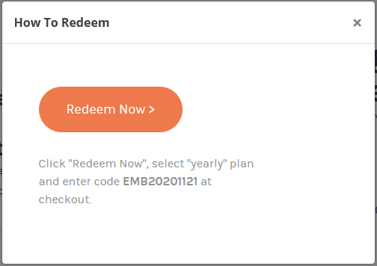

Controls description:

* This content is taken from [Offer->[How To Redeem] field](#_Offers). See details in the [chapter Admin Interface-> Offers](#_Offers).

## Page ‘Pro Workshops’

[Note Nov 21, 2020 from Sam: Just promotional content – no actual videos or functionality available to any member at this time.]

It may look like this (for illustration only), included into [Main Template](#_Template_‘Main’).

|  |
| --- |
| **[Leaderboard]**  **[UAG]**  **[Banner]** |

Controls description:

|  |
| --- |
| The main page content is ‘Coming Soon’.  Actual content and functionality will be provided in Phase 2. |
| Section ‘Leaderboard’ and ‘UAG’ are the same as on the [Home page](#_Page_‘Home’_1).   * NOTE: ‘Leaderboard’ should take the whole page width. See creative in Zeplin. |
| Section ‘Banner’. Can be provided later and coded like simple HTML block on a page. It does not require any description. |

[NEXT VERSION: all description below are for next phase, not for Phase 1 =>

[PM: Nov 19, 2020 from Sam - describe

<https://app.asana.com/0/607038627868623/1199155964593989>

|  |
| --- |
| **Summary of New Functionality:   “Workshops”   General:** Collection of videos posted for paid Pro Members to access, intended to offer educational content to members across a variety of topics.  **List of Workshops** –  Workshops are not date-specific like Networking Events. These are permanent videos posted to the site searchable by category/sub-category. I suggest we also add tags to each for additional filtering options. [Open Issue: I recommend to keep it simple: one category and videos, without sub-category. Usually people do search by keywords, not by category or sub-category]  [SF Thank you, Sergey. However, we will have a lot of videos in a year and we’ll need to have such categorization for a better user experience when browsing the site)]  Example:  PRO WORKSHOPS   [Summary Listing Page]  CATEGORY: BUSINESS  Subcategory: Sales & Marketing  Subcategory: Operations and HR  Subcategory: Billing and Finance  CATEGORY: LAWN CARE  Subcategory: Tools & Maintenance  Subcategory: Planning & Design  CATEGORY: LANDSCAPE  Subcategory: Tools & Maintenance  Subcategory: Planning & Design  CATEGORY: HARDSCAPE  Subcategory: Tools & Maintenance  Subcategory: Planning & Design  AK note: Note that this has to be reflected in our footer  https://lh6.googleusercontent.com/MikFO13i3orDRUBEYRUQsy6CFETkdQy0VNDUscTCxNC7By0rmgy0elD69g8LBS60HNmex8M-eRILPgZhbsyiBNUMRVt63yIM7mT7tCnKhA4QlEKcEJ8JnRXbp5RT4PUkrw7rcVw  Within each sub-category we could have 1 to N videos of various lengths.  Clicking on any of these opens Workshop Detail Page [Open Issue: So, the Details page is for each Video, not for each Sub-category? The page below is a subcategory details page? ]  [SF: For phase one, I think we only need a detail page for the specific video, not for category or subcategory pages. Each PRO Workshop video will be individual and listed under Category/Subcategory. We will not have courses with Lesson 1, Lesson, 2...etc. within as shown in this mock up.  )]  https://lh3.googleusercontent.com/Twc5gduv0VX5xoePHvZi_nkpXIldHe6reCK_RUkPOsOvyMqGnqCZGkrxtuZxOc5gxLYqUi0oLOKyImVzfETsZ9I9h8BjzJ4QsQNVNTTE2LoLSA7alH8g4C5RWWPIkGDtqd4edPE  Each video could have one or more tags associated to it, which are clickable to sort onscreen listing to showcase all videos using that tag, such as “Trimmer” or “Backpack Blower”. Tags should be able to be created by site admin only.  TBD: Hosting platform. We want these videos to only be viewable on our site and only to Pro-Members who are either on trial or permanent Pro member status.  Can this be done with Vimeo? Or do we need a hosting platform?   NOTE: As this is a paid membership access video, we can’t have 3rd party advertising appear before or during the video. [SP>Vimeo should not allow you to download videos. Also paid plan does not display any ads or related videos like YT]  The Workshop Detail page should include: [Open Issue: there is no creative yet. Correct? At least I did not find it in the Zeplin] [SF: Not that I am aware. [Angelina Kwok](mailto:angelina@senseimarketing.com) ]  AK: There is creative but needs to be edited now based on this document. I will get this revised.   * Thumbnail image * Full image (based on page design) * Title * Description * Workshop leader (name of person delivering the workshop) * Length of workshop * [future phase] Recommended for: “Beginner”, “Intermediate”, or “Expert” * [future phase] Preview trailer (short teaser video) * List of recommendations (manually added) * Watch Now button [Open Issue: One workshop - one video only. Is it possible that one workshop can have N videos? If yes, then we need to rethink about structure of workshops and what will be displayed in listing]  [SF: All Workshops will be singular for this year. ] * Share Function * Star Rating ( 1 – 5 star rating) * “Recommend This Workshop”  [Allows user to leave a written testimonial for the Workshop (max 500 characters?).   + When added, user must click “accept terms and conditions” and then “submit recommendation.”   + Recommendations are saved to the database and accessible by admin user   + Admin user can add testimonials to the Workshop detail page per page design   **Accessing Workshops**   * All videos can be accessed by anyone with a Pro Member status. * Public and Basic users can see the page with listings but cannot view the video. (NOTE: In future phases, we may have a video trailer for each workshop video that the public can view) [Open Issue: but they can open Video page details, in other case no sense to share it. Correct?][SF: Yes, all users can open/view the detail page (just like public users can open RLG offer detail page) but only PRO users can click to view videos] AK: Sergey – can you let me know how this page should be mocked-up for public users, if required? * There is no limit to the number of workshops members can have. [Open Issue: Video and workshop are synonyms (the same here)?  [SF: Yes, I’m sorry. “Workshop” is a “Video” ]] * Workshop links/images should be able to be shared via social media, email, etc. like other content; however, the video should not be viewable to anyone who is not a Pro Member. [Open Issue: allow to share video page details, but play video for Pro Members only. Correct?] [SF: Yes, detail page can be shared but only PRO members can open the video. When a non-PRO member tries to view the video, message appears that this Workshop is for PRO members only with link to “Enroll” or “Log In”. [Angelina Kwok](mailto:angelina@senseimarketing.com) I think we need Laura to provide creative for this. [Robert Clarke](mailto:robert@senseimarketing.com) do we need to have a plan to add non-PRO members to contact database? How do we help convert them here? ]   **Poll**   * At the end of the video, Pro Members should be presented with a short poll asking 5 questions about the video they watched. * Question: I would like the poll to ONLY display once the video is fully viewed by the member. Is this possible? [SP: Vimeo provides API to check if people viewed till the end, but they cannot guarantee if a user scrolled to the end or watched till the end. Also, it can confuse people if we open Poll immediately after they watched it, because they may want to watch it again. System should be very flexible. I recommend less restrictions and rules in Phase 1, so we can adjust them later after using a month or more] [SF: Because we are offering points and badges for completing Workshops, we need some mechanism/business rule to know they are not simply clicking on videos or just answering poll without watching video? I’m open to suggestions] * They must complete the poll by answering the questions (either yes/no or multiple-choice answers). [Open Issue: what happens if they do not answer it properly or do not want to answer? Do not allow to watch other videos, other sub-categories? I would recommend to skip it or to move this requirement into NEXT PHASE. If people already paid for videos (for membership), why should we restrict them by Polls?] [SF:This is not a test where a specific grade is required. All Worskshop videos are singular and not dependent on others to be watched or completed (for this year). However, I would like to consider if we can make “successfully answered” poll questions (E.g. only allow one incorrect answer) before the user gets points for completing the Workshop?? ] * The poll would be the same format but different questions for each workshop video * When the survey is completed, the user should get an on screen confirmation and any associated points or badges should be awarded at this point (see points/badges)   AK: Sergey – sometimes polls can be embedded in videos. Is this something Vimeo can support, or shall I get a mock-up for this too? Will it overlay the video? |

]

-//-

[PM: Nov 19, 2020

Recommend this workshop (this will be a written testimonial as opposed to share)

Let's create a pop-up form for this. Include "accept terms & conditions" check box; submit recommendation button

This is only for Pro-users

Public and basic users can see all the info but cannot actually see the video - they must sign-in/register for this. So perhaps this should be a pop-up?

[@Sergey Peregud](https://app.asana.com/0/571416341975099/list) - FYI. I have not included the things for phase 2 (preview workshops, level of workshop (intermediate, beginner, etc). I have also not included the poll as I'm not sure how it will function as discussed in [Workshop Summary](https://app.asana.com/0/0/1199155964593989).

Hi @Sergey Peregud Workshop Details Page has changed and uploaded onto Zeplin if you'd like to review over them. We just changed the top section of this page which you can see in the image references below. We have included a "recommendation pop-up" where if they click the recommendation button - a pop-up will appear and they can submit a review.

Public Users/Basic Member = 1 Screen

Pro Member = 1 Screen

You can find these screens under section: Pro Workshops - Details Page



|  |
| --- |
| **[Pro Tips]**  **[Leaderboard]**  **[UAG]** |



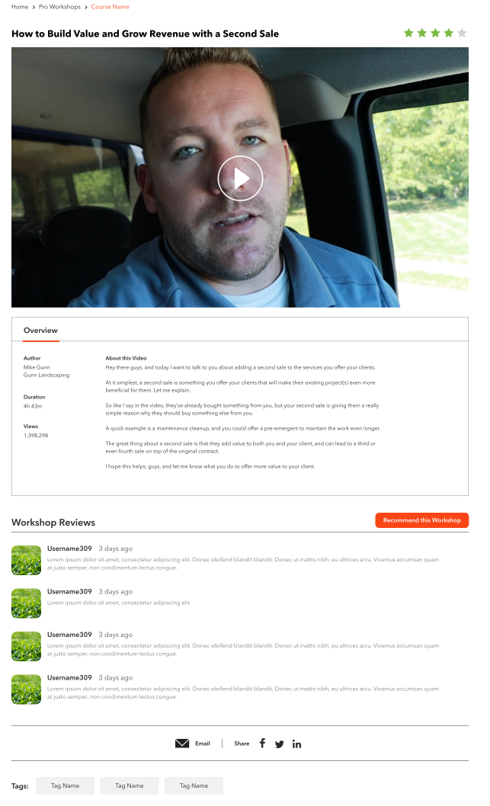

Why do we need this popup:

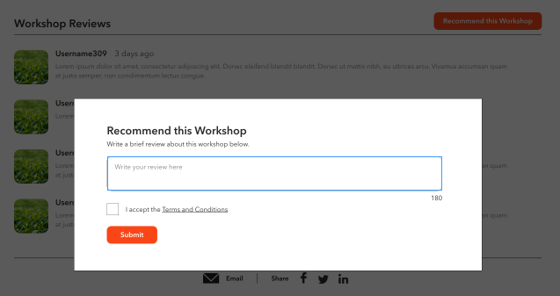

]

Features:

* on-site notices, and push notifications to the Mobile App will alert member of the available course, and remind participants when the next lesson is ready to complete.
* The curriculum will include multi-chapter, multi-lesson courses. Example:
  + **Marketing Course**
    - Lead Generation Lesson / Test [Open Issue: what does it mean ‘TEST’? How it should work?];
    - Website Optimization Lesson / Test
    - Social Media Marketing / Test
    - Referrals and Influence Marketing Lesson / Test
  + **Human Resource Course**
    - Hiring & Managing Students / Test
    - Retaining Staff Throughout Winter / Test
  + **Operational Courses**
    - Maintaining Equipment – Best Practices / Test
    - Maintaining Equipment in the Off Season / Test
* Summaries for each lesson will be available to all;
  + however, each lesson must be completed before the next lesson can be fully accessed and completed. A short survey will be presented at the end of each video lesson to ensure understanding of the concepts presented. [Open Issue: are lessons – only videos? Can it include text and images for example or mix of all? Where videos will be hosted: on website, CDN, Youtube? It is not so important, but can affect fucntionality];
* Lessons can be watched/completed on any device and at any time.
  + There’s no time limit on the curriculum’s completion (unless desired).
* Certificate of completion, which will be awarded to participants in the year the curriculum was completed. [Open Issue: please provide creative how page with a certificate may look like. Also need creative for certificate – is if PDF?];
* Additional rewards such as online badges and website widgets will be developed so that completion of the curriculum may be used as a status and certification on the members website and social media.
* Offer a “lite version” of the curriculum for non-subscribed professionals. [Open Issue: I would recommend to have a ‘lite’ version as a separate curriculum, not like a restricted part of the exiting one. So ‘lite’ version should not be available for PRO members. Correct?]

[Open Issue:

MOBILE:

* please provide creative for mobile:
  + lists
  + curriculum details]

[Oct 1, 2020 from team call]

|  |
| --- |
| Phase 1   * series workshop * one program * series of videos in different categories * can watch on demand * [PM: Do we need a stream video services for video?] * How to track watch video – it depends on a video streaming approach * Want to know who watched till the end * Track when people drop-off * Add poll or survey at the end   + 5-6 questions   + Unlock other video after answers |

## Page ‘Pro Networking’

This page displays active and passed events.

It may look like this (for illustration only), included into [Main Template](#_Template_‘Main’).

|  |
| --- |
| **[Leaderboard]**  **[UAG]**  **[Banner]** |

Controls description:

|  |  |  |  |  |  |  |  |  |
| --- | --- | --- | --- | --- | --- | --- | --- | --- |
| **Top banner**  Top banner depends on user membership:   |  |  | | --- | --- | | **Membership** | **Details** | | FREE | Example:  Clicking ‘Start My Free Trial’ opens [Registration page](#_Forgot_Password) in the same window. | | BASIC | Example:    Clicking ‘Become a Pro member’ opens [‘Membership Subscriptions’ page](#_Page_‘Membership_Subscriptions’) in the same window. | | PRO | NO top banner for this membership for now. | |
| **Upcoming Events**    This section displays all upcoming events.   * Upcoming event mean ([[Event Date] + [Start Time]](#_Events)) > (current date/time). [Tech Note: Event Date and Start Time are in EST for each event. So, need to convert user local time into EST before comparing these date/time]; * If there are no upcoming events, then this section is empty; * Sort events by [[Event Date] + [Start Time]](#_Events) in DESC order. Means show those which will happen soon at the top; * Each event includes. The whole section is a link to open [‘Pro Network - Details’ page](#_Page_‘Pro_Networking) in the same window. See event fields description in [Admin->’Events’ chapter](#_Events):   + Tile Image;   + Event Date and Start Time;      * + - Date format: <short weekday name>, <short month name> <day>     - Time format: 12hr format.   + Event title;   + Tile Short Description;      * + Button ‘View Event’. This is a link to open [‘Pro Network - Details’ page](#_Page_‘Pro_Networking) in the same window. |
| **Past Events**    This section displays past event where ([[Event Date] + [Start Time]](#_Events)) >= (current date/time). [Tech Note: Event Date and Start Time are in EST for each event. So, need to convert user local time into EST before comparing these date/time]   * If there are no past events, then this section should be hidden including the black top horizontal bar; * Sort events by [[Event Date] + [Start Time]](#_Events) in ASC order. Recent at the top; * Each event includes. The whole section is a link to open [‘Pro Network - Details’ page](#_Page_‘Pro_Networking) in the same window. See fields description in the ‘*Upcoming*’ section above.   + Tile image;   + Event title;   + Tile short description;   + Button ‘Watch Now’. This is a link to open [‘Pro Network - Details’ page](#_Page_‘Pro_Networking) in the same window. |
| Section ‘Leaderboard’ and ‘UAG’ are the same as on the [Home page](#_Page_‘Home’_1).   * NOTE: ‘Leaderboard’ should take the whole page width. See creative in Zeplin. |
| Section ‘Banner’. Can be provided later and coded like simple HTML block on a page. It does not require any description. |
| [NEXT VERSION: add a filter like this or like here: <https://demo.theeventscalendar.com/>    ] |

### Page ‘Pro Networking - Details’

This page displays event details.

Page content depends on [user membership](#_Membership_/_User) and Post->[Availability Mode].

It may look like this (for illustration only), included into [Main Template](#_Template_‘Main’).

|  |
| --- |
| **[Leaderboard]**  **[UAG]**  **[Banner]** |

Controls description:

Legend:

* ***Event State***: [Tech Note: Event Date and Start Time are stored in EST for each event. So, need to convert user local time into EST before comparing these date/time]
  + **Active Event**: ([[Event Date] + [Start Time]](#_Events)) < (current date/time).
    - It means that event is not passed yet;
  + **Past Event**: ([[Event Date] + [Start Time]](#_Events)) >= (current date/time).
    - It means that this event passed.

|  |
| --- |
| - this is post title. |
| this is Post->[Event Date] and Post->[Start Time].  If *Event State* is **Past**, then if it should be a grey like this: |
| **Access section**    This section visibility and content depends on user [Membership](#_Membership_/_User) and Post->[Available Mode].   |  |  |  | | --- | --- | --- | | **Membership** | **Post-> [Available Mode]** | **Details** | | FREE | Any type | Content of this section should be taken from [Content Blocks](#_Content_Block), because in such case we can easily modify its HTML content via LiveCanvas.  Name of this section in the Content Blocks should be ‘*Pro Networking – Restricted Access – Start Free Trial*’.  Clicking ‘FREE’ or button opens [Registration page](#_Forgot_Password) in the same window. | | BASIC | - Pro Only | Content of this section should be taken from [Content Blocks](#_Content_Block), because in such case we can easily modify its HTML content.  Name of this section in the Content Blocks should be ‘*Pro Networking – Restricted Access – Join Now*’.  Clicking ‘Pro Member’ or button opens [Membership Subscriptions page](#_Page_‘Membership_Subscriptions’) in the same window. | | BASIC | - Basic and Pro | Do not display this section | | PRO | Any type | Do not display this section | |
| **Event content section**  This is Post->[Event Content]. Any HTML content including a video.  Its visibility depends on user [Membership](#_Membership_/_User) and Post->[Available Mode]. See below:   |  |  |  | | --- | --- | --- | | **Membership** | **Post-> [Available Mode]** | **Section ‘Event Content’** | | FREE | Any type | Hidden | | BASIC | Pro only | Hidden | | BASIC | Basic and pro | Visible | | PRO | Any type | Visible | |
| This is Post->[Content]. Any content which describes this post.  It is visible for all users, so it should not include Membership dependable content or details. |
| **RSVP section**  [Open issue to Angelina: provide mockup: <https://app.asana.com/0/1178924434621079/1199384632388572> ]  This section is used for Active Events only and allows members to select if they are Going or Not.    Its visibility depends on user [Membership](#_Membership_/_User) and Post->[Available Mode]. See below:   |  |  |  |  | | --- | --- | --- | --- | | **Membership** | **Post-> [Available Mode]** | **RSVP** | | | **Active Event** | **Past Event** | | FREE | Any type | Hidden | Hidden | | BASIC | Pro only | Hidden | Hidden | | BASIC | Basic and pro | Visible | Hidden | | PRO | Any type | Visible | Hidden |   Controls description:   |  | | --- | | - Post->[Event Date] in format: ‘Monday, December 10’. | | - Post->[Start Time] and Post->[End Time] [Tech Note: Convert times from EST to local client time] | | - this is a link on Post->[Event URL] in a new window. | | opens [‘Add to Your Calendar’ popup](#_Popup_‘Add_to) to select what type of calendar to use. | | **Going/Not Going section**  - These how these buttons look like by default.  When user clicks ‘*Going*’ then:   * System sends email to this user as described in Post->[section ‘Event Details Email’];   + Use these fields from *Post->[section ‘Event Details Email’]* for sending email:     - [FROM Name];     - [FROM Email];     - [Subject];     - [Body]. * System adds this user details into Post->[Attendee] with [Status] = ‘*Going*’, including date/time when email above was sent; * Changes the section on this one:  |  |  | | --- | --- | | If more than one users are going. [Tech Note: you can get how many people are going checking Post->[Attendee]->[Status]]. | This is how it looks like if only this user is going. |  * + Clicking ‘Change your RSVP’ opens a popup to change status. This popup may look like this:      * + - Clicking ‘*Going’* just closes the popup without any changes in RSVP status. This is because user already has ‘*Going*’ status;     - Clicking ‘Not Going’ does the following:       * Changes Post->[Attendee]->[Status] on ‘*Not Going*’ for this user;       * Display RSVP section as described below for ‘*Not Going*’ status;       * Closes the popup.     - Clicking ‘Cancel’ just closes the popup without any changes in RSVP status for this user.   When user clicks ‘*Not Going*’:   * If user does not exist in Post->[Attendee]->[User] yet, then adds a new record, otherwise update [Status] to ‘*Not Going*’ for the existing one:   + [User] – user ID;   + [Status] = ‘Not Going’;   + [Details email sent at] – no changes in this field. If it was previously provided when user set ‘*Going*’, then do not reset it, in other case next time if user clicks *Going,* then system will send event email again to user => as a result user will may receive a lot of duplicated emails. * Section is changed on this one below (‘*Not Going*’ button is selected): | | - this is how many members are going. If there are no going members in Post->[Attendee] (where [Status]=*’Going*’), then do not display this section. | |
| [NEXT VERSION: Like functionality  ] |
| **Share section**    The same as described on the [page ‘Pro Tips -Details’](#_Page_‘Pro_Tips), but with these parameters   * + - Metatags details:  |  | | --- | | <meta property="og:title" content="<post title>"/>  <meta property="og:description" content="< post excerpt (if empty then generate excerpt from WP) >"/>  <meta property="og:site\_name" content="<website name from WP Settings>"/>  <meta property="og:url" content="<full path URL on this post >"/>  <meta property="og:image" content="<full path URL to [tile image]>"/>  <meta property="twitter:card" content="summary\_large\_image"/>  <meta property="twitter:title" content="<post title>"/>  <meta property="twitter:image" content="<full path URL to [tile image] as for **og:image**>"/>  <meta property="twitter:description" content="<the same as for **og:description**>"/>  <meta property="twitter:url" content="<full path URL on this post>"/>  <meta property="twitter:creator" content="Echo Means Business"/> | |
| **Comments section**  Adding comments:   * This section is controlled by WP and is available for logged in users only. So, WP should display something asking to log in to leave a comment     [NEXT VERSION: add points and replies] |
| **Section ‘Get to Know Pro Members’**    This section is described in the [chapter ‘Section ‘Get to Know Pro Members’’](#_Section_‘Get_to). |
| Section ‘Leaderboard’ and ‘UAG’ are the same as on the [Home page](#_Page_‘Home’_1).   * NOTE: ‘Leaderboard’ should take the whole page width. See creative in Zeplin. |
| Section ‘Banner’. Can be provided later and coded like simple HTML block on a page. It does not require any description. |

[NEXT VERSION: review missing details]

|  |  |
| --- | --- |
| <https://app.asana.com/0/607038627868623/1199155964593988>  **Summary of New Functionality:   “Networking”   General:** List of future Zoom meetings listed for member review and registration. Zoom meetings will be recorded and posted to “Networking” section of the site for review by all Pro Members.  **List of Networking Events** – Presented by Date (most recent), and can follow similar layout to what we did for CPA’s Powered by Payroll  **https://lh3.googleusercontent.com/SUKxUPz6PVyOBwMJDcYCFi-MZtVkn80P47fxy0-TPScOmM162B3kZfpfEn1ikRyOC_KrCLZLDD0Pdfi8LfMXG93oPATsEMvuetuUFOw6DRaRUQVQD0HqSU_mp1wjKRzJ-RIFtqc**  **Setting up Networking Event:** Admin user will create Networking Event via CMS (if possible [SP: Yes]) by adding event name, event description, event host (optional), special guest (optional), date, start time, end time, webinar log in information.  Presentation of the data is based on style guide for the section [SP: I think it is not important how admin interface will look like]. [SF: I didn’t mean admin interface, I meant it should fit in the public-facing site style guide]  **Registration for Events (phase one)** -   1. Pro Member [Open Issue: only Pro Members can register. Corect?] [SF: Correct.]clicks “Register for this Event,” which opens review/confirmation pop up or screen:   You are registering to attend this EMB Pro Networking Event:  Event Name: Event Date: Event Time:   Your Name:  Your Email Address:   <confirm\*>   [Open Issue: why need to ask to confirm email, if they already logged in? I would recommend to use one email for all cases to simplify workflow and functionality] [SF:I am OK removing this. You are correct that we have their email address if they are logged in. My question: Is there any value in pre-populating their email address so we can continuously confirm that we’re using the right email address for them? I’m OK removing it if you don’t think this is necessary]  AK: Note in the future that some events will be available to basic users. Not for phase 1.  \*by confirming your participation, you agree to EMB Community Rules and Terms and Conditions.   1. “Confirmation”    1. Confirmation of event registration appears on screen with details and the following options:       1. Cancel Registration,       2. Save to Calendar,       3. Share to social media,       4. Share to email    2. Email confirmation is sent to the Pro Member with Confirmation of event registration appears on screen with details and the following options:       1. [Open Issue: do we need ‘Cancel Registration’?]  [SF:This would be good option to have if they know they will not attend when we send reminders. It can be phase two if necessary)]       2. Save to Calendar,       3. Share to social media,       4. Share to email    3. 5 days before the event: Reminder Email    4. 1 day before the event: Reminder Email    5. Morning of the event: Reminder Email (can we plan this to be X-hours before the scheduled start of the event?) [SP>yes]   **Past Events (phase one) –**   * When events pass, the status of the event should be changed to “Past Event” and remain on the site. A video will be posted (manually) [Open Issue: until video is loaded we should display a placeholder] [SF: I believe we can create either a default “event replay coming soon” image to use when an event is 1-day old, until a video is uploaded.]to past events with a recording of the event for Pro-Members to see. [Open Issue: recorded events for Pro Members only as well. Correct?]  [SF: Correct, PRO members only.]   https://lh5.googleusercontent.com/tt5kG8xM0A7S_kP8Kj2qEThzseSfH_7pSQcVilyG1I8ThdzrtQEj77SPrUK-5tKqCCeFoh9zux8R95K_L4eZDP0tC_aqHFq1Yg7G5ztHbSyeNlrI4y-V0PBKUfmUhMEFwTJiF-Y   * Samples of this video may be created by Sensei’s team for promotional purposes on the general site (for public viewing) with a link to the full video (but can’t be seen unless they upgrade to Paid Member)   https://lh6.googleusercontent.com/KkXEd5is0vb4Svn0G9N8cSnB8j2_-Rd9E_fZo_3nZiv_Tkhn4Tioc5R8x1oip27BbBltaGCB5Eq25vVpdMkuF0bvKNGHnBzQWHd2XOWg_3sjfv4mW7AA6cld2INlhSlozkC2A_M   * Suggest we add ‘tags’ to all events so that users can sort videos and events by tags   **Other notes:** [SP: next version]  - There is no live broadcast of the Zoom meeting on the website. It will happen on Zoom.  - For phase one, we can have unlimited number of people registering for events. In future phase we may set limit, which means website application must be able to track the number who are registering and present a message “sold out” when  - All events are free to Pro Members. No e-commerce or money is required for registration to networking event.  - Users who register for an event must be tracked with a note in their profile that they registered for the event.  QUESTION/COMMENT: We also need to verify that the user attended the event, which I suspect we’ll have to do manually? What suggestion can be made for this? Have a Sensei admin upload list of those who attended the event? Or manually “check off” those who attended the event in the admin site? [SP: we can track if people attended an event by generating a special link which they click to open a Zoom link. But this will not guarantee that they presented at the event.   [SF: Let’s try it. ]  Yes, via admin interface we can add a feature to select who participated - as an option]  [SF: Yes, please. )] |  |

#### Popup ‘Add to Your Calendar’

This popup is used to display options how user can add event details into his/her calendar.

It may look like this (for Illustration only):

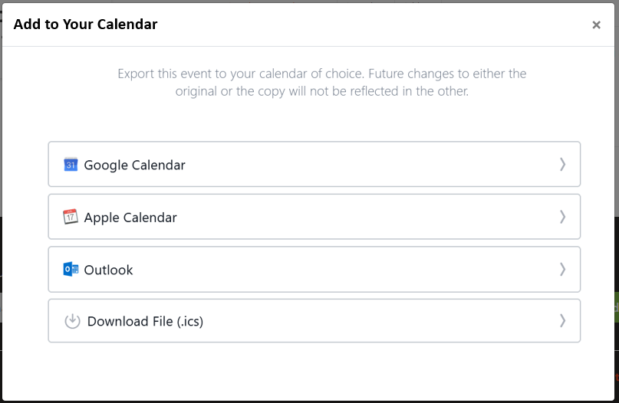

Controls description:

* **Google Calendar** is a link in Google Calendar format in a new window to open Google calendar;
* **Apple Calendar** is a link in Apple Calendar format on a file to open Apple calendar;
* **Outlook Calendar** is a link in Outlook Calendar format on a file to open Outlook calendar;
* **Download File** is a link in .ICS format on a file to download it (do not open Apple or Outlook calendar – just download like a regular file);

Links should be generated automatically by the system for each events when this popup opens.

[IMPORTANT: DO NOU USE 3rd party web services to generate Calendar links, because they may stop working any time. We need to code this on our side or using some plugins]

[Tech Note: here are some webservices to generate links manually

* For Google Calendar: <http://kalinka.tardate.com/>
* For Outlook/Apple and ICS: <https://ical.marudot.com/> ]

Each Link/File should include:

|  |  |
| --- | --- |
| **Calendar Fields** | **Post fields** |
| Event Title | Post->[Title] |
| Date/Time From | Post->[Event Date] + Post->[Start Time]  Set Timezone to EST |
| Date/Time To | Post->[Event Date] + Post->[End Time]  Set Timezone to EST |
| Description | Post->[Content] |
| Location | Option, can be empty |
| All Day | Optional, can be empty.  If required then use ‘No’ |
| URL | Option, keep empty. If required, then use Post->[Permalink] |

## Page ‘Pro Missions’

[PM: describe this from Angelina, Nov 30, 2020

Asana: <https://app.asana.com/0/1178924434621079/1199334175014065>

To confirm, yes, this would be pretty much identical to the CPA challenges, except that we will have other types of Missions (see Points tab under Mission of the Week:

<https://docs.google.com/spreadsheets/d/1nBFBaD2FtEHmWyJ3Zm5aMI1fgdKMMPkUK4o4SHdR69E/edit#gid=0>

]

[PM: discuss and describe this module]

It may look like this (for illustration only), included into [Main Template](#_Template_‘Main’).

|  |
| --- |
|  |

### Details page

Complete a mission:

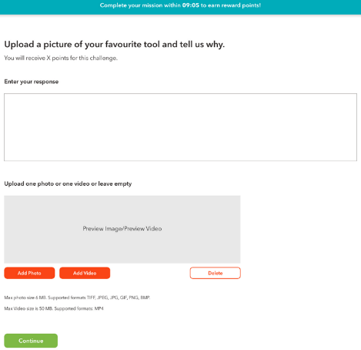

[PM: I think this should be part of the page above – preview mode]

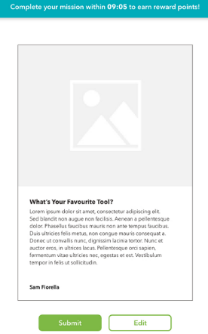

Page with submitted results:  
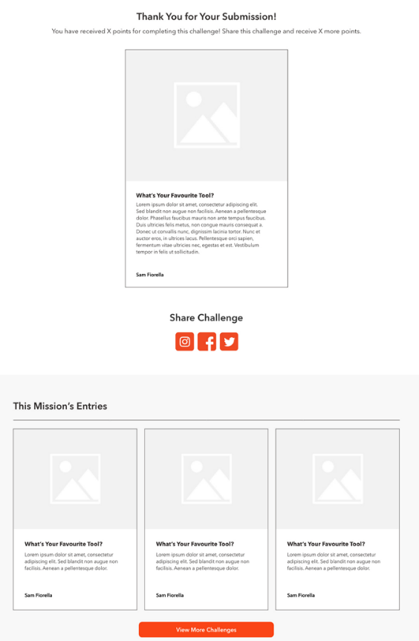

## Page ‘Membership’

This page is used to provide details about available memberships and prices.

[PM: describe this page]

## Page ‘Leaderboard’

This page displays list general info about leaderboard, rank users and how to get points.

It may look like this (for illustration only), included into [Main Template](#_Template_‘Main’).

|  |
| --- |
|  |

Controls description:

|  |
| --- |
| **Top banner**   * Simple image and text. Let edit via LiveCanvas as part of page content |
| **Page content**    This is Page->[Content], editable via LiveCanvas. |
| **Your Rank section**    All fields are the same as described for the section ***Leaderboard*** below, but for the logged in user.  Section with a logged in user points.   * Do not display this section if:   + [Update Jun 19, 2018] If user is not Logged In;   + If user does not have points for the active tab;   + [Update Nov 28, 2020. I decided always display a user rank]~~User is included into Top 10;~~   + User role is not [Eligible for participating in Leaderboard](#_Section_‘Get_to). |
| **No scores section**    This message is displayed if there are no people for the selected Month, year or Mentor. |
| **Leaderboard section**      Description:   * Tabs ‘This Month’, ‘This Year’, ‘Mentor’ – the same as in [chapter Appendix->‘Leaderboard’](#_Section_‘Get_to).   + Each tab displays 10 users by default. * User data - the same as in [chapter Appendix->‘Leaderboard’](#_Section_‘Get_to) * Link ‘View More’.   + Hidden if there are less than 10 users in the list.   Clicking ‘View More’ adds additional 10 users at the end of the lists   * ‘View More’ can maximum open 200 records. |
| **Earn Points section**   * This section is part of page content and can be editable via LiveCanvas.     [NEXT VERSION:   * Display this section in Phase 2 or 3: ‘Mission of the Week’]   Links:   * Join. Opens [‘Forum’ page](#_Forum_1) in the same window; * Sing Up. Opens [‘Pro Networking’ page](#_Pro_Workshop_(Public) in the same window; * Redeem. Opens [‘Pro Rewards’ page](#_Pro_Reward_(Partner) in the same window. * ‘.. points here’ opens [page ‘Points and Badges’](#_Page_‘Points_and) in the same window. |

### Page ‘Points and Badges’

This page displays list points and badges.

It may look like this (for illustration only), included into [Main Template](#_Template_‘Main’).

|  |
| --- |
|  |

Controls description:

* Badges images are provided in [chapter ‘Badges’](#_Badges).

## Page ‘Become a Member’

This page may look like this:

|  |
| --- |
| C:\Users\Sergey\AppData\Local\Temp\snap_screen_20170326201943.png  C:\Users\Sergey\AppData\Local\Temp\snap_screen_20170326202012.png |

[Dev Note: we should use v3CATCHA – invisible one]

Controls:

* [Tech Note: use conditional logic from Gravity forms for these fields below]:
  + Country.
    - Drop-down with two values only ‘United States’ and ‘Canada’
      * ‘United States’ should be selected by default
  + State / Province
    - If country ‘United States’, then:
      * Field Label: ‘State’
      * Drop-down values: list of US states, sorted in ascending order, empty by default (if possible)
    - If country ‘Canada’, then:
      * Field Label: ‘Province’
      * Drop-down values: list of Canada provinces, sorted in ascending order, empty by default (if possible)
  + ZIP / Postal Code
    - If country ‘United States’, then:
      * Field Label: ‘ZIP’
      * Textbox, empty by default
    - If country ‘Canada’, then:
      * Field Label: ‘Postal Code’
      * Textbox, empty by default
* Spanish and French.
  + Checkmarks. All unselected by default. Not mandatory

When user clicks SUBMIT then:

* Do validation
* Save results into DB
* Send email to admins

|  |  |
| --- | --- |
| FROM | <website name> <no-reply@website domain> |
| TO | <take emails from form settings, usually admin emails>  **For LIVE only:** barb\_gora@echo-usa.com; Cynthia\_Pilch@echo-usa.com |
| CC | <take emails from form settings, usually admin emails>  **For LIVE only:** sam@senseimarketing.com; se@senseimarketing.com |
| SUBJECT | ECHO Means Business – member application submitted |
| BODY | [Dev Note: I recommend to use a plugin to display values automatically]  ECHO Means Business – member application submitted.  <all fields from the form>  ECHO Means Business |

* + Where:
    - If country ‘United States’, then:
      * Field labels: ‘State’ and ‘ZIP’;
    - If country ‘Canada’, then:
      * Field labels: ‘Province’ and ‘Postal Code’.
* Send e-mail to user who submitted this form

Font: Courier New, 10

|  |  |
| --- | --- |
| FROM | <web site name><no-reply@website domain> |
| TO | <user first and last name> <user’s e-mail> |
| SUBJECT | Your UAG Application |
| BODY | Hello, <first name>.  Thank you for your recent application for membership in the 2021 ECHO User Advisory Group (UAG). Please note that all applications will be reviewed in the fall of 2020.  This program is a 100% volunteer organization of professional landscapers, arborists, and other grounds maintenance pros dedicated to supporting others in the industry with value-added content related to managing their equipment, customers, and businesses.  NOTE: While the UAG is a council of professionals who help lead this community, there are still many opportunities for you to add your experiences, feedback, and content! We encourage you to continue to visit [www.echomeansbusiness.com](https://www.echomeansbusiness.com), log in, and participate in the online forum and other engagement tools we're adding each month.  If you're interested in contributing to ECHO Means Business with blog posts or videos, you may be interested in our Contributor program. If so, please send an email to [angelina@senseimarketing.com](mailto:angelina@senseimarketing.com) and she will follow up on your interest.  Your active participation in the community will be considered during next year's membership selection process.  You can also download the [ECHO Means Business mobile app on Android and iOS](https://www.echomeansbusiness.com/pages/emb-mobile-app), and connect with fellow pros as well as upload photos and videos of your work.  Thank you,  Member Services  The ECHO User Advisory Group |

* + Android: <https://play.google.com/store/apps/details?id=com.sensei.emb.android&pcampaignid=MKT-Other-global-all-co-prtnr-py-PartBadge-Mar2515-1>
  + iOS: <https://itunes.apple.com/us/app/echo-means-business/id1367138226?mt=8>
* Show confirmation message.

|  |
| --- |
| Thank you for your application for membership in the ECHO User Advisory Group (UAG). |

## Page ‘Contributors’

This page displays list of UAG member contributors.

It may look like this (for illustration only), included into [Main Template](#_Template_‘Main’).

|  |
| --- |
|  |

* Section ‘Contributors’.
* ACF, control type: repeater. Elements: users.
* It allows to select ‘Contributor’ members in a given order from the list of all users.

|  |  |  |  |  |  |  |  |  |  |
| --- | --- | --- | --- | --- | --- | --- | --- | --- | --- |
| |  |  |  | | --- | --- | --- | |  | **Contributors** |  | | 1 | <User 1> | ⮿ | | 2 | <User 2> | ⮿ |   Add Contributor |

* User details. The same as on the ‘[UAG members’ page](#_Page_‘UAG_Members’_1).
* Links ‘Apply for 2021 Membership’ and ‘become a contributor here’. The same as on the ‘[UAG members’ page](#_Page_‘UAG_Members’_1).
* Button ‘Request info’ has the same link as ‘become a contributor here’.

## Page ‘UAG Members’

This page displays list of UAG members.

It may look like this (for illustration only), included into [Main Template](#_Template_‘Main’).

* Content example: <https://www.echomeansbusiness.com/client/user-advisory-group.jsf>)

|  |
| --- |
|  |

Content description:

* Section ‘UAG Council Members’.
* ACF, control type: repeater. Elements: users with the checkmark ‘UAG member’.
* It allows to select ‘Council’ members in a given order from the list of all users with the checkmark ‘UAG member’.

|  |  |  |  |  |  |  |  |  |  |
| --- | --- | --- | --- | --- | --- | --- | --- | --- | --- |
| |  |  |  | | --- | --- | --- | |  | **Council members** |  | | 1 | <UAG member 1> | ⮿ | | 2 | <UAG member 2> | ⮿ |   Add Council member |

* + User details:

|  |
| --- |
| This section may look like this: |
| - User photo. This is **Users->Avatar**. |
| - User name. This is **Users->Display Name**. |
| - user business name. This is **Users-> Business Name**. |
| - user networks.  This is a list social networks from **Users->Social Links**.  All links should open pages in a new tab.  Display only those links where URL is provided, otherwise do not display.   * For example: this user does not have Twitter – this its URL is not displayed |
| - user’s posts on this or 3rd party websites.  This list is taken from **Users->Posts**.   * Clicking name should open article in a new tab.   If user does not have **Users->Posts,** then this section including its name should not be displayed.  - user first name, plus **‘s.** Must be taken from **Users -> First Name**. |

* Section ‘User Advisory Group Members’.
* ACF, control type: repeater. Elements: users with the checkmark ‘UAG member’.
* It allows to select ‘UAG members’ in a given order from the list of all users with the checkmark ‘UAG member’.

|  |  |  |  |  |  |  |  |  |  |
| --- | --- | --- | --- | --- | --- | --- | --- | --- | --- |
| |  |  |  | | --- | --- | --- | |  | **User Advisory Group members** |  | | 1 | <UAG member 1> | ⮿ | | 2 | <UAG member 2> | ⮿ |   Add User Advisory Group member |

*  - Link to [‘Become a Member’ page](#_Page_‘Get_the). It opens in the same tab.
*  - Link to [mailto:angelina@senseimarketing.com?subject=Contributor Program](mailto:angelina@senseimarketing.com?subject=Contributor%20Program).

## Page ‘Meet the Pros’

[PM: Nov 19, 2020

<https://app.asana.com/0/607038627868623/1199159747519125>

|  |  |  |  |  |  |  |  |  |  |  |  |  |
| --- | --- | --- | --- | --- | --- | --- | --- | --- | --- | --- | --- | --- |
| **Summary of New Functionality:   “Meet the Pros”   General:** Listing of all member profiles (summary listing and details) with options to connect and chat with other members.  **Meet the Pros Workflow:**   1. \Basic or Pro Members can open Meet the Pros within navigation to view a list of all Pros (summary listing page). [Open Issue: Pros - are they all registered users? If not, please clarify] [SF: Pros are enrolled/logged in members (Basic or Pro)] 2. Filter options for this listing [Doc for all filters: <https://docs.ultimatemember.com/article/1513-member-directories-2-1-0> ]    1. By State [Open Issue: they allow you to do it by location, including State. Demo: <https://ultimatememberdemo.com/members/?map_zoom_2d7fb=4&map_sw_2d7fb=19.440131131418923%2C-145.60418624974042&map_ne_2d7fb=41.873206489480495%2C-54.54949874974043&location_search_2d7fb=Texas%2C%20USA&view_type_2d7fb=grid> ]      * 1. By Type [Open Issue: what does it mean TYPE?] [SF: In member user profile, in addition to name, email and password, we’d like to ask the following:  Role: Business Owner \_\_ Operator \_\_ Services Provided: Lawn Care \_\_ Landscape\_\_ Hardscape\_\_ Arbor\_\_   In this or next phase, we hope to allow logged in member to sort the view of other members by “type” which is “Role” or “Services Provided” ]  1. Summary listing of each pro to include basic info such as Name, Short “about” summary, head show, point level, most recent badge award. Members can click to view profile.    1. (Viewing profile (based on design by Laura), information to include: “about” “posts” “comments” “activity” “messages” “Badges” and “Friends” as outlined in functional specification for “Ultimate Member” ) 2. User sends a message to another Pro who responds 3. User sends Friend request to another Pro and is accepted 4. Badges are earned when completed, see spreadsheet with Badges  |  |  | | --- | --- | | Connector Level 1 | Messages and “Friends” 5 pros | | Connector Level 2 | Messages and “Friends” 25 pros | | Connector Level 3 | Messages and “Friends” 100 pros | | Note | 1 pro is considered returned message and accepted friend request to same Pro user |  1. Points earned when completed (see point spreadsheet)  |  |  |  |  | | --- | --- | --- | --- | | Profile | Meet a Fellow Pro | Points awarded when member Messages (must be two-way communication) with another member AND becomes friends with them. (both actions have to be taken) | 200 |   [SP: I am not sure yet how to implement checking for #4,5,6 and 7 above. It can be easy, or may require extensive coding. Cannot estimate until we start this. May take 2-3weeks for coding] [SF: Let us know. If we have to move this to phase two, I would be OK with that although I would prefer to keep it in phase one because it’s important to getting engagement on site]  **[Example from Demo**  [**https://ultimatememberdemo.com/members/?map\_zoom\_2d7fb=4&map\_sw\_2d7fb=19.440131131418923%2C-145.60418624974042&map\_ne\_2d7fb=41.873206489480495%2C-54.54949874974043&location\_search\_2d7fb=Texas%2C%20USA&view\_type\_2d7fb=grid**](https://ultimatememberdemo.com/members/?map_zoom_2d7fb=4&map_sw_2d7fb=19.440131131418923%2C-145.60418624974042&map_ne_2d7fb=41.873206489480495%2C-54.54949874974043&location_search_2d7fb=Texas%2C%20USA&view_type_2d7fb=grid) **]**  This is how Member directories looks like    [SF: This is OK. I don’t think we need to include star rating for individuals however. I see it has a search feature/filter (drop down), which is great. We don’t need to search by “gender” but can we add filter searches for “State” “Role” and “Services Offered”? |

]

[Open Issue: please provide details:

* what should be displayed on this page – is it regular Directory of all website users?
* what should be opened by clicking ‘View more’
* need to discuss other features like ‘Chat’

View for Logged in Basic and Pro users

### Public User – Gateway (please login pop-up)

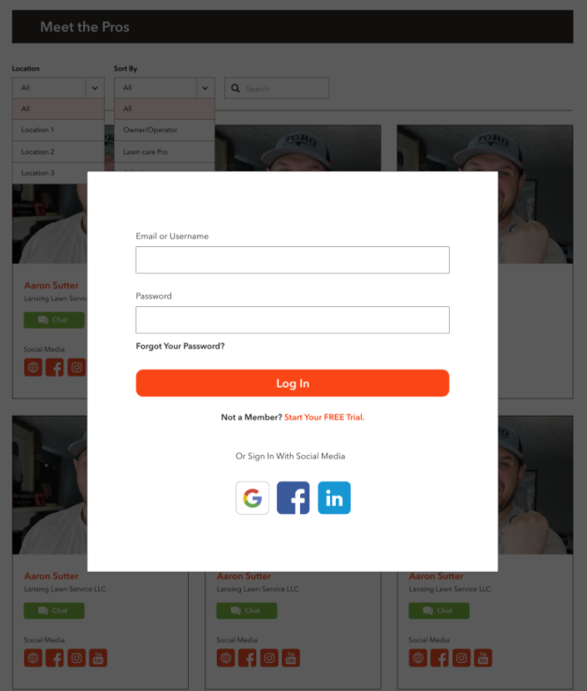

### Public, Basic & Pro User

|  |
| --- |
|  |

## Pages ‘About Us’, ‘Privacy Policy’, ‘Terms’, ‘Community Rules’, ‘FAQ’

All pages are included into the [Main Template](#_Home_Page).

Privacy Policy page:

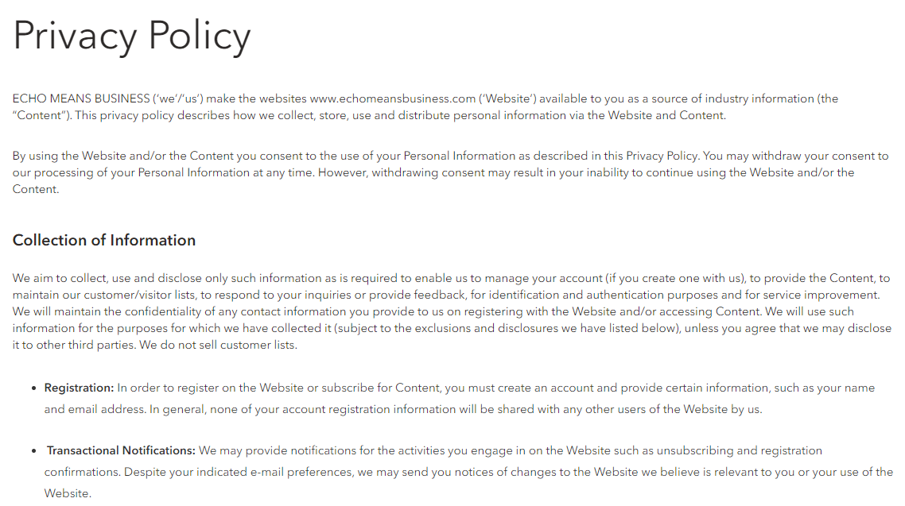

About page:

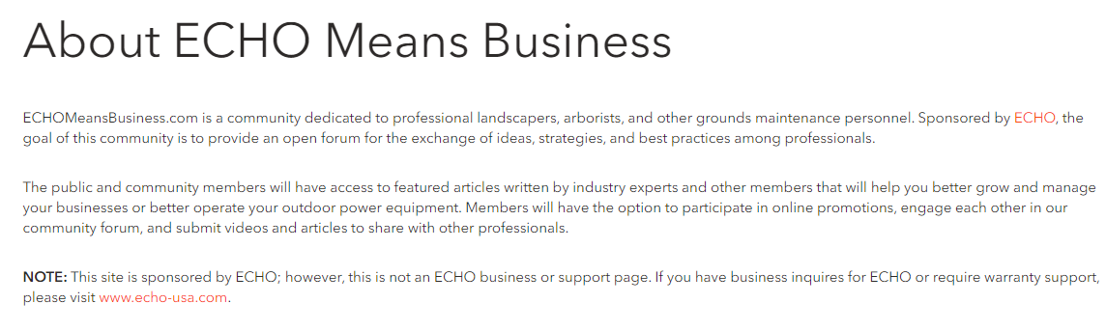

Terms & Conditions page:

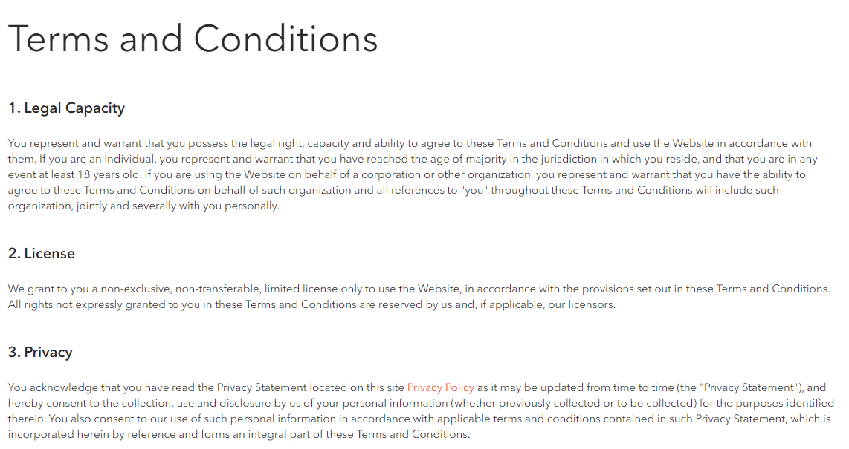

Community Rules page:

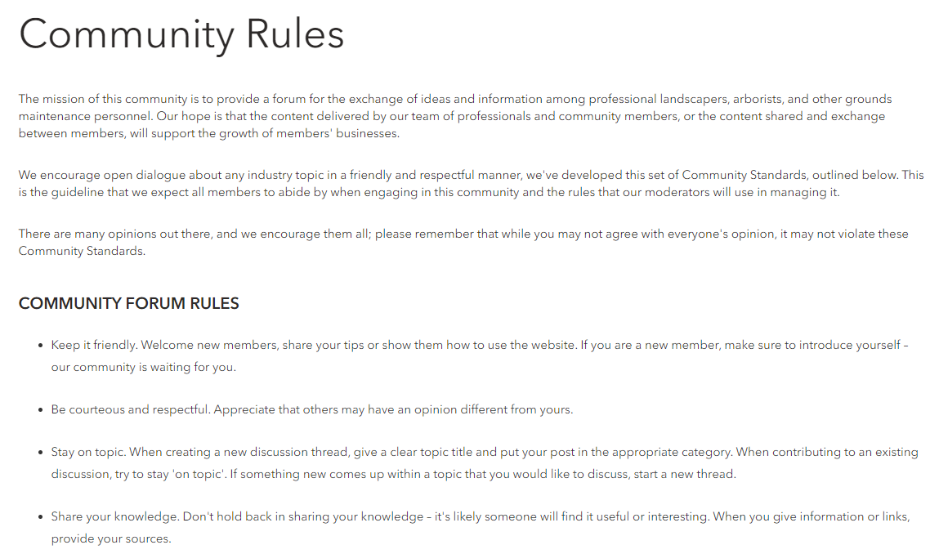

FAQ:

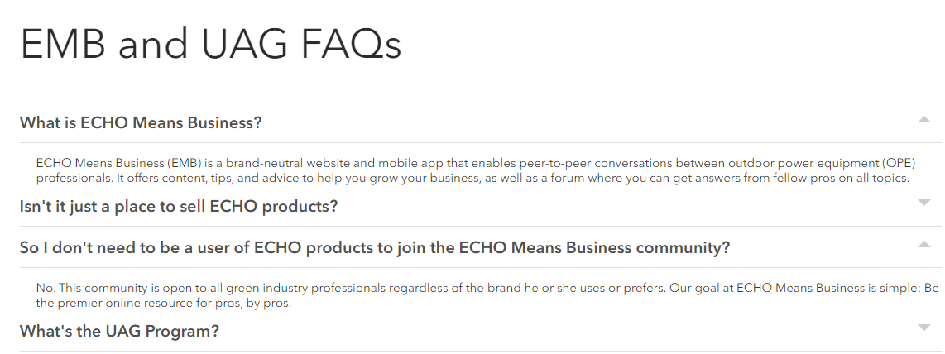

## Page ‘Get Mobile App’

This page may look like this

<https://www.echomeansbusiness.com/pages/emb-mobile-app>

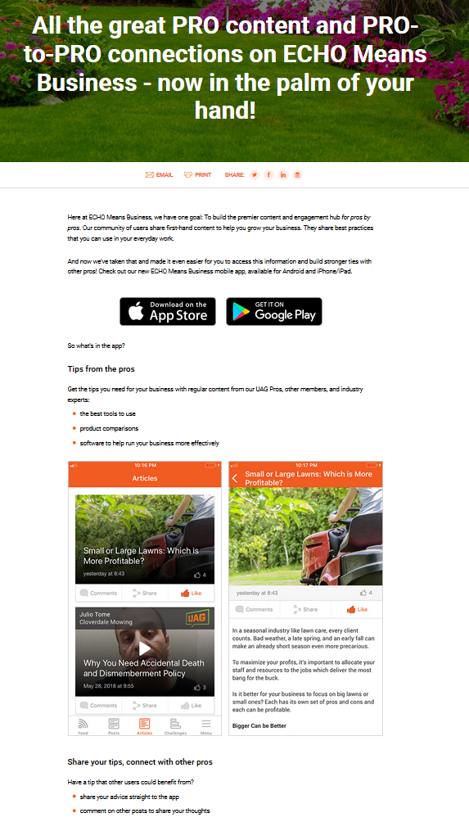

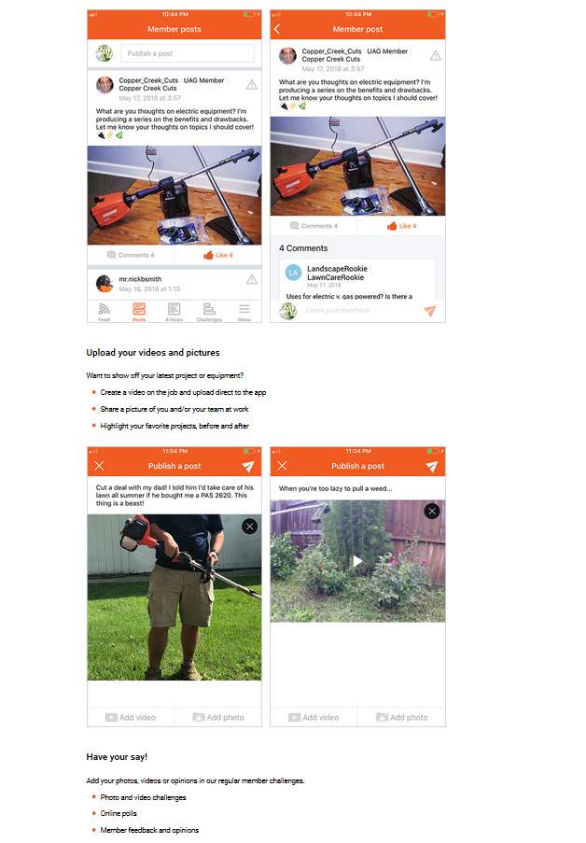

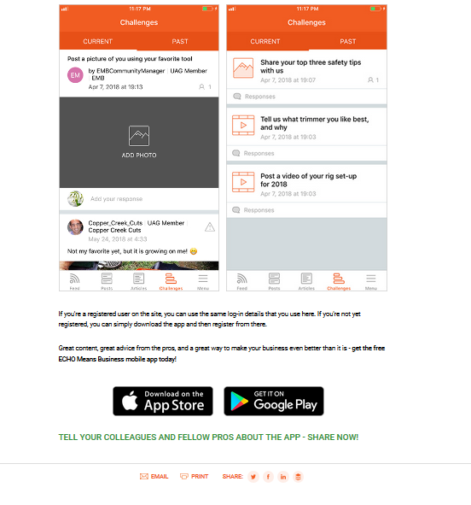

## Page ‘Membership Pricing’

[PM: describe: table price with links on Membership Subscriptions. Need to think how not logged in user can register and get required membership, because we already have a registration page from UM]

### Page ‘Membership Subscriptions’

[PM: describe: plugin Restricted Content Pro – for logged in user only]

# Administrative Interface

## Page ‘EMB Settings’

These are settings which will be used across the website.

It may look like this:

|  |  |  |  |  |  |  |  |
| --- | --- | --- | --- | --- | --- | --- | --- |
| **EMB Settings**   |  |  | | --- | --- | | **Pro Rewards** |  | | **Featured Pro Rewards**  *List of offers to be displayed on all pages*   |  |  |  | | --- | --- | --- | | Existing offers | ->  <- | Selected featured offers | | | |

Controls description:

* Tab ‘Pro Rewards’
  + Featured Pro Rewards. This section is used to choose what offers to display in this section on the website:

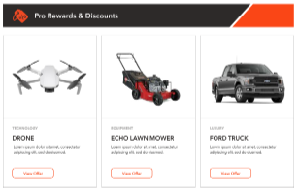

## Users

Section for UAG members. This section will include the following fields:

|  |  |  |
| --- | --- | --- |
| **Field Name** | **Field Type** | **Description** |
| UAG Member | ACF | This is a checkmark:   * Default value is unselected; * If this checkmark selected, then it means that this user is UAG member. |
| Social links | ACF | This is a list of users’ social networks.  NOTE: some users may have two channels on one platform.  ACF Repeater. Fields:   * Social Network Name. Textbox, optional, empty by default.   + Default list of Networks:     - Website     - Facebook     - Instagram     - Twitter     - YouTube * Network URL. Webpage URL, optional, empty by default.  |  |  |  |  |  |  |  |  |  |  |  |  |  | | --- | --- | --- | --- | --- | --- | --- | --- | --- | --- | --- | --- | --- | | **Social links**   |  |  |  |  | | --- | --- | --- | --- | |  | **Name** | **URL** |  | | 1 | <social network 1> | <network URL 1> | ⮿ | | 2 | <social network 2> | <network URL 2> | ⮿ |   Add social link | |
| Posts | ACF | User’s posts on this or 3rd party websites.  NOTE: user may do not have posts, or one post or more.  ACF repeater. Fields:   * Post Name. Textbox, mandatory, empty by default. * Post URL. Webpage URL, mandatory, empty by default.  |  |  |  |  |  |  |  |  |  |  |  |  |  | | --- | --- | --- | --- | --- | --- | --- | --- | --- | --- | --- | --- | --- | | **Posts**   |  |  |  |  | | --- | --- | --- | --- | |  | **Post Name** | **Post URL** |  | | 1 | <post name 1> | <post URL 1> | ⮿ | | 2 | <post name 2> | <post URL 2> | ⮿ |   Add user post | |

## Pro Tips

Pro Tips is a custom post with standard Categories and Tags.

Pro tips ACF properties

|  |  |  |
| --- | --- | --- |
| **Field Name** | **Required** | **Details** |
| **Image** | Yes | This is image on a tile  Example:    [Tech Note: old images will have a grey block at the top, but new images will not have it. The grey block will be displayed if UAG Member was provided] |
| **Presentation Mode** | Yes | Radio button:   * Article. Should be selected by default * Video   Based on this field we display a play button over a tile. Example for Video: |
| **Mobile Content** | No | This is HTML editor  Empty by default.  It is used for displaying pro tip on mobile devices, because mobile devices cannot display reach HTML properly from Custom Post->Content property. |
| **UAG Member** | No | User ACF control.  If provided then this block below will be displayed above the image |

## Offers

Offer is a custom post with standard Categories and Tags.

ACF properties

|  |  |  |
| --- | --- | --- |
| **Field Name** | **Required** | **Details** |
| **Tile Image** | Yes | This is image on a tile  Example: |
| **Tile Short Description** | Yes | Text on a tile  Example: |

## Content Blocks

Content Block is a custom post, which will be used for visual coding HTML blocks via LiveCanvas.

Custom post properties:

* Not public. Should not be available by a post URL on public website;
* No indexing. Should not be indexed and included into search results.

WP Content Block List:

* Add a new column to display a shortcode for each block, like this

|  |
| --- |
| **Shortcode** |
| [emb-content-block id=<X>]  Where <X> is object ID |

WP properties (no Advanced Custom Fields are required)

|  |  |  |
| --- | --- | --- |
| **Field Name** | **Required** | **Details** |
| **Tile** | Yes | This is name for block.  It will not di displayed anywhere on the website. We will use it to identify blocks.  Example: ‘*All pages - Pro Networking*’ |
| **URL** |  | We are not planning to use it.  WP will create URL automatically. |
| **Content** | Yes | This content will be used like shortcode in places where we want to display this content. |

## Events

Event is a custom post with standard Categories and Tags.

Properties

|  |  |  |  |
| --- | --- | --- | --- |
| **Field Name** | **Type** | **Required** | **Details** |
| **Title** | **WP** |  | This is event name |
| **Permalink** | **WP** |  | This is URL on the [Pro Networking - Details page](#_Page_‘Pro_Networking) |
| **Content** | **WP** |  | This is event description which will be visible for all users: FREE, Basic and Pro |
| **Event Content** | **ACF,**  **HTML** | No | This is an event video (embedded code of video player) or demo video or ‘coming soon’ message. It depends on what we decide to add here.  Visibility of this section depends on Availability mode and Event Date/Time. See [chapter ‘Pro Networking - Details’](#_Page_‘Pro_Networking) for rules. |
| **Availability Mode** | **ACF** | Yes | This is radio button with two options:   * **Pro Only** (selected by default) * **Basic and Pro**   This mode regulates who can access this event and how it will look like. |
| **Tile Image** | **ACF, Image** | Yes | This is image which will be displayed in the list of event  Recommended size: 455 x 259px  Example: |
| **Tile Short Description** | **ACF,**  **HTML** | No | This is a short content on a tile. Can be plain or HTML  Example: |
| **Event Date** | **ACF,**  **Date Picker** | Yes | Date control to select date when event starts in EST timezone. |
| **Start Time** | **ACF,**  **Time Picker** | Yes | This is time when event starts in EST |
| **End Time** | **ACF,**  **Time Picker** | Yes | This is time when event ends in EST |
| **Attendee** | **ACF,**  **Repeater** | No | This repeater will contain those who is Going or Not Going on this event.  It includes:   * **User**. Control to select a user name;   + Empty by default * **Status**. Empty by default. Drop-down with options:   + Going   + Not Going * **Details email sent at**. This is date/time in EST when ‘Event Details’ email was sent to this user. This field is required to avoid situations of sending this email more than one time if user changes ‘*Status*’.   + Once email is sent then this field date/time is not changed even if user changes his status from Going to Not Going and back.   [NEXT VERSION: when admin adds user into this list and sets status to ‘Going’ then system should send ‘Event Details’ email, the same way as it is if user does it on public website] |
| **Event URL** | **ACF,**  **URL** | Yes | This is 3rd party URL for event.  It can be Zoom link or any other link. |
| **Sub-section ‘Event Details Email’**  This section defines what email will be sent to user when user first time changes event status on ‘Going’. | | | |
| **FROM Name** | **ACF,**  **Textbox** | Yes | This FROM name.  Default value: **Echo Means Business** |
| **FROM Email** | **ACF,**  **Textbox** | Yes | This is FROM email address.  Default value: **no-reply@echomeansbusiness.com** |
| **Subject** | **ACF,**  **Textbox** | Yes | Subject name.  Default value: **EMB Event details** |
| **Body** | **ACF,**  **HTML** | Yes | Email body.  This should be Plain HTML, without complicated hierarchy, because standard HTML editor may break email structure. |

## Offers

Offer is a custom post with standard Categories and Tags.

Properties

|  |  |  |  |
| --- | --- | --- | --- |
| **Field Name** | **Type** | **Required** | **Details** |
| **Title** | **WP** |  | This is offer title |
| **Permalink** | **WP** |  | This is URL on the [Pro Reward-Details page](#_Page_‘Pro_Reward) |
| **Content** | **WP** |  | This is offer details |
| **Availability Mode** | **ACF** | Yes | This is radio button with two options:   * **Pro Only** (selected by default) * **Basic and Pro**   This mode regulates who can see redeem this offer and how it will look like. |
| **Tile Image** | **ACF** | Yes | Tile image  Example: |
| **Offer Logo** | **ACF** | Yes | This is an image this will be displayed below the title.  Example (in red):    [Tech Note: even if logo is look like a text, it is an image. Let convert text into image and apply for offer. No need to support two logos: image and text. Text logos will be quite rarely] |
| **How To Redeem** | **ACF** | Yes | This is a link on item from [Content Blocks](#_Content_Blocks).  Example:    We will add redemption instructions for each offers as HTML inside Content Blocks with names ‘*Offer – How to redeem - <offer name>*’ and select which one will be used in a popup on [Pro-reward-Details page](#_Page_‘Pro_Reward).  When How to Redeem popup is displayed then we will read HTML from Content Block and display it inside popup. |

# Appendix

## General Website Sections

These are sections which are often used on more than one page across the website.

[Tech Note: I recommend to add these sections into Content Blocks are reuse across the website like shortcodes. Shortcodes may use parameters to manipulate sections content]

### Section ‘Leaderboard’

Features:

* Sorting rules by points
  + If points are equal, then sort by Activity Date/Time. Example:

|  |
| --- |
| Place 1. Points: 100. Last Activity: Jan 1, 2018 13:10  Place 2. Points: 100. Last Activity: Jan 1, 2018 13:11  Place 3. Points: 100. Last Activity: Jan 6, 2018 11:00 |

**Eligible** user – it’s a user role ‘Subscriber’ and ‘Member’.

Only eligible users are displayed in the Leaderboard.

This section may look like this

|  |  |
| --- | --- |
| This is how it looks like if it is in left or right sidebar | This is how it looks like by all website width: |

Description:

* ‘*Community Leaderboard Every action has a reaction! Read articles, join discussions, watch videos - every time you interact on the site, you’ll gain points. See how many you can score!*’ – Static text;
* Leaderboard displays on [Eligible](#_Leaderboard) users;
* Tabs:
* [NEXT VERSION: Mentor]

|  |
| --- |
| Description:   * Total points earned based on the following activity:   1. Responding to Forum Questions   2. Responding to AMAs   3. Participation in Networking Events |

* This Month. Active by default. It shows top 5 users with max points during the current month;
* This Year. Active by default only if there are no users on the ‘This Month’ tab. It shows top 5 users with maximum points during the current year;

Notes:

* If there are no users on a tab then display this message ‘*Leaderboard scores are updated daily.*’
* [Nov 30, 2020: I decided include such user and display their username instead] ~~Include only those users into the list who has at least First or Last name completed.~~ 
  + ~~If user do not have First and Last names, then do not include his/her into the list.~~

User data:

* Number. It’s a position in the Leaderboard;
* User avatar;
* User name from **Users -> First and Last Name**;
  + If both First and Last are empty, then display **User->Username**;
* Active:
* Note: [Last Activity] – it’s date/time when user last time earned points.
* If [Last Activity] < 24hr, then ‘Today’.
* If 24hr <= [Last Activity] < 48hr, then ‘Yesterday’.
* Otherwise: [Last Activity] date (in EST timezone), format: Dec 01, 2020.
* Points. Summary for this month or for this year, based on the active tab.

‘FULL LIST’ – Link to [page ‘Leaderboard’](#_Page_‘Leaderboard’). It opens in the same window.

### Section ‘Get to Know Pro Members’

This section may look like this:

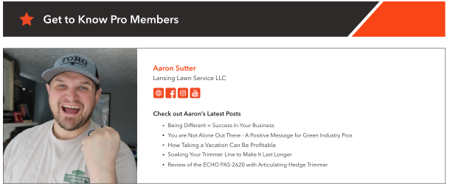

Controls description:

* This section **randomly** displays some UAG member details. New UAG member is displayed each time when page is refreshed;
* Section/user details are described in the [chapter ‘UAG Members’](#_Page_‘UAG_Members’_1), with one exception:
  + UAL member image is displayed differently than on [page UAG Members](#_Page_‘UAG_Members’_1), see how it should look like on example above.

### Section ‘Pro Members You May Know’

This section is displayed for users with [Free membership](#_Membership_/_User) only. [Tech Note: use UM shortcode to show/hide it]

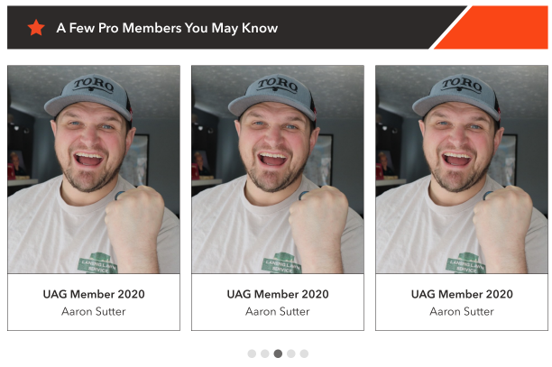

[Design Note: avatars are 150x150px. So need to modify creative for square photos]

Controls description:

* Randomly display 5 UAG members. These are users who has **[UAG Member] = True** in profile. [Tech Note: Algorithm: 1) get amount of UAG members; 2) choose randomly a number from 1 to [UAG amount-5]; 3) then display next 5 members starting from this number].
* User tile. NOT a clickable tile, just a carousel
  + User avatar;
  + User company name
  + User name

Task: <https://app.asana.com/0/607038627868623/1197821910033353>

[Angelina, Oct, 15, 2020: At this stage, we hope that this section will be randomized profiles of any basic + pro member (no click-through)]

[NEXT VERSION: display user details by clicking on it tile

]

### Section ‘Listen to the EMB Podcast’

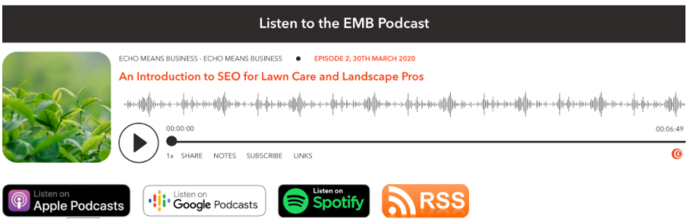

[Tech Note: code it like a shortcode or widget]

* ‘Listen to the EMB Podcast’ – Static text.
* Buttons:
* Listen on Apple Podcasts – Link to <https://podcasts.apple.com/ca/podcast/echo-means-business/id1502311446>. It opens in the new tab.
* Listen on Google Podcasts – Link to <https://podcasts.google.com/feed/aHR0cHM6Ly9mZWVkcy5jYXB0aXZhdGUuZm0vZWNoby1tZWFucy1idXNpbmVzcy8>. It opens in the new tab.
* Listen on Spotify – Link to <https://open.spotify.com/show/0NWOFOeWIlw7Ts2WGxfNVb>. It opens in the new page.
* RSS - Link to <https://feeds.captivate.fm/echo-means-business/>. It opens in the new tab.

### Section ‘Pro Tips’

[Tech Note: I recommend to add this section into Content Blocks like ‘*All pages – Pro Tips*’. HTML will include top horizontal section and shortcode to display categories and slider]

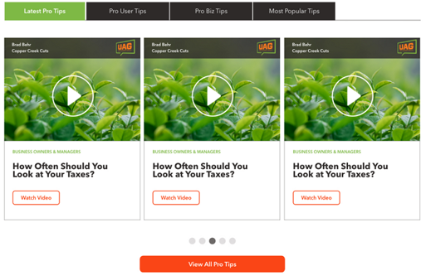

|  |
| --- |
| **Categories**  List of categories:    This section should include only the following items:   * **Latest Pro Tips**. Includes 5 recently added pro tips, sorted by date/time in descending order;   List of the categories which have at least one pro tip. The category name which is shown includes the name and ‘ Tips’ (dash and ‘Tips’).  NOTE: do not show the category, if it doesn’t have pro tips.   * **Pro User Tips**. Includes max 5 recently added pro tips into ‘*Pro User*’ category, sorted by date/time in descending order; * **Pro Biz Tips**. Includes max 5 recently added pro tips into ‘*Pro Biz*’ category, sorted by date/time in descending order; * [NEXT VERSION: **Most Popular Tips**].   Clicking these items changes slider with pro tips below. [Tech Note: use AJAX to update slider without reloading the page] |
| **Slider**    Slider includes:   * 5 pro tips based on selected category. Each pro tip includes: * The whole block is clickable. It opens same as ‘Watch Video’ (or ‘View Pro Tip’);   + Image; [Tech Note: User name, company name and UAG icon are part of image].   [NEXT VERSION: display user name, company and UAG icon automatically];   * + - If pro tip type is ‘*Video*’, then display play icon above the image;       * No hover ;       * Hover     - If **Pro Tips->UAG Member** was provided, then we show grey overlay with First and Last user name, Business Name, and UAG image.      * + Category name. If article has more than one category, show only one in ASC order;   + Pro Tip title;   + Button - Link to the page ‘[Pro Tip Details](#_Pro_Tips_–)’ It opens in the same window. Link depends on pro tip type (Video or Article), and can be:     - Watch video;     - View pro tip. * - Slider navigation. Clicking these items scrolls to particular pro tip; * Button to open page [‘Pro Tips by Category’](#_Pro_Tips_By) with all pro tips in the selected category.   + Button name should be ‘**View All**’ for all categories [Tech Note: I do not want to change button name based on the select category in this phase].   + DO NOT display this button when ‘**Latest Pro Tips**’ section is selected [Tech Note: this section is not a WP category, so it can be difficult or unclear what to display when ‘View All’ button is clicked]. |

### Section ‘Pro Forum’

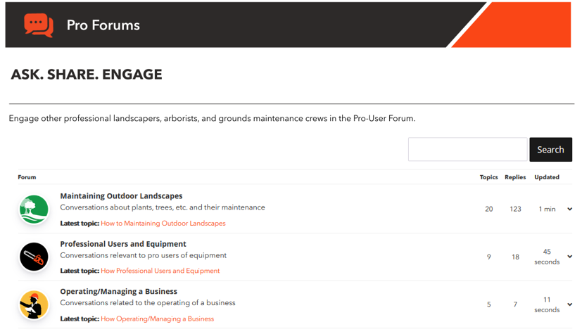

[Tech Note: this is WPForum plugin]

### Section ‘Pro Rewards’

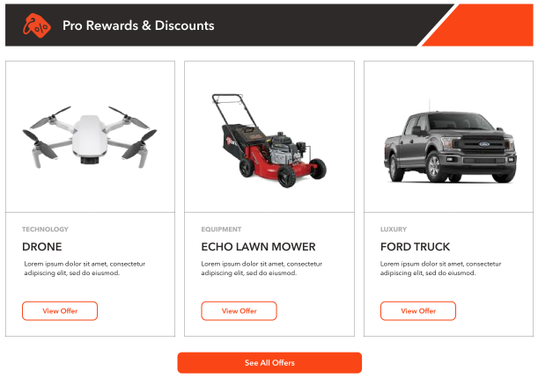

Controls description:

* Section title is static HTML;
* List of pro rewards is taken from [EMB Options->Pro Rewards->Featured Pro Rewards](#_Page_‘EMB_Settings’).
  + It displays items in the same order as in EMB Options;
  + It can have 1 or more items, not exactly 3. [Testing Note: check that this section will properly display 1,2,3,4,5,6 items];
  + Item. The whole tile is a link the same as ‘View Offer’
    - [Tile Image](#_Pro_Reward);
    - Category, e.g., ‘*Technology’*, ‘*Luxury’*;
      * If there is more than one category for pro reward, then display only the first one sorted by category name in ASC order;
    - [Tile Short Description](#_Pro_Reward);
    - View Offer. Opens [‘Pro Reward - Details’ page](#_Page_‘Pro_Reward) in the same window.

‘See All Offers’ button – Link to the [Pro Rewards page](#_Pro_Reward_(Partner) in the same window.

### Section ‘Pro Workshops’

[Nov 30, 2020: this is temporary copy for Pro Workshop section (in Zeplin):

* No links
* Just image and content

]

It may look like this:

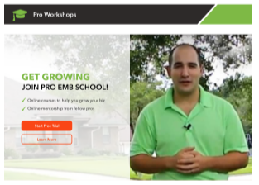

This is HTML block can be customized via [Content Blocks](#_Content_Block).

* Learn More. Opens [‘Pro Workshops’ page](#_Page_‘Pro_Rewards’) in the same window.

[Open Issue to Angelina: provide copy for Phase 1: <https://app.asana.com/0/1178924434621079/1199242527772224> ]

[NEXT VERSION: add links on actual workshops]

### Section ‘Pro Networking‘

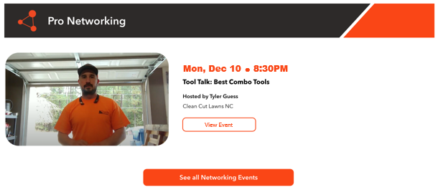

Controls description:

* Display one event where (Event->[Event Date] and Event->[Start Time]) < (the current date/time).
  + If there are > 1 such events, then sort events by **[Event Date and Start Time]** in ASC order and choose the 1st one. Means display event which will start soon;
  + If there are no such events, then display this:



* Event details are described on the [page ‘Pro Networking’](#_Pro_Workshop_(Public).

‘See all Networking events’ button – Link to the [‘Pro Networking’ page](#_Page_‘Pro_School’) in the same tab.

### Section ‘UAG‘

It may look like this:

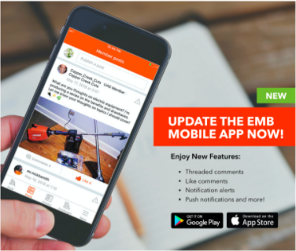

This is HTML block can be customized via [Content Blocks](#_Content_Block).

* The whole block should be a link on [page ‘Get Mobile App’](#_Page_‘Get_Mobile) in the same window;
* Google Play link: <https://play.google.com/store/apps/details?id=com.sensei.emb.android&pcampaignid=MKT-Other-global-all-co-prtnr-py-PartBadge-Mar2515-1>
* App Store link: <https://itunes.apple.com/us/app/echo-means-business/id1367138226?mt=8>

### Section ‘Check These Out’

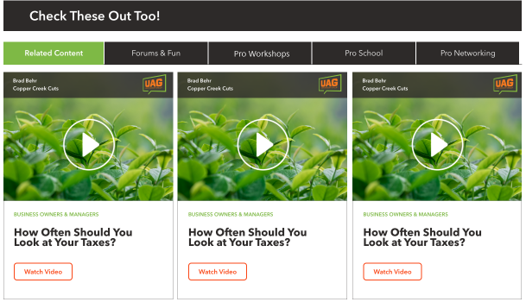

In general this section includes 5 tabs:

[Tech Note 1: we will use Content Blocks for some of these tabs/blocks below. But Content Blocks will include the horizontal bar with section name as well. So, maybe we can use a special parameter in a shortcode which will show or hide the horizontal bar based on where this block is displayed]

[Tech Note 2: some tabs will not be displayed on some pages. For example ‘Forum & Fun’ should not be displayed on the ‘Forum’ page]

* [NEXT VERSION: Related Content. It takes time to describe and code how articles will relate to offers and visa versa. This is why I moved into the next version]
* **Forum & Fun**.
  + Clicking this tab opens the same content as described on the [Hope page for the Forum](#_Page_‘Home’_1). It may look like this (for illustration only)

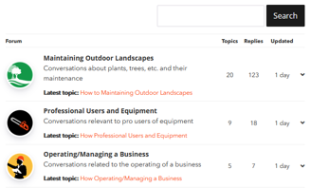

* **Pro Rewards**. This tab is selected by default.
  + Clicking this tab opens the same content as described on the [Hope page for the Pro Rewards](#_Page_‘Home’_1). It may look like this (for illustration only)

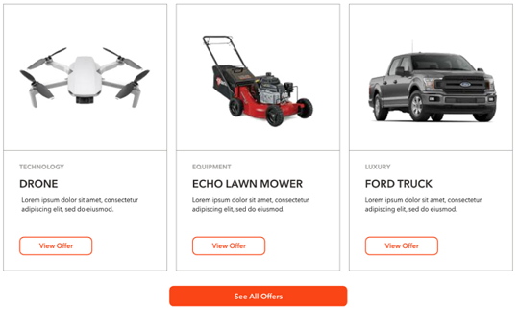

* + - NOTE: Button at the bottom of this block should be displayed as well
* **Pro Workshops**. Clicking this tab opens the same content as described on the [Hope page for the Pro Workshops](#_Page_‘Home’_1). It may look like this (for illustration only)

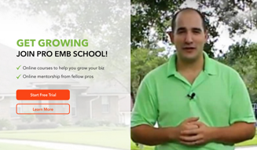

* **Pro Networking**. Clicking this tab opens the same content as described on the [Hope page for the Pro Networking](#_Page_‘Home’_1). It may look like this (for illustration only)

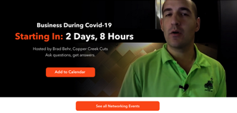

* + - NOTE: Button at the bottom of this block should be displayed as well

## Membership / User Roles

Website membership roles:

|  |  |  |
| --- | --- | --- |
| **Membership** | **Name on the main website** | **Description** |
| Free | Not applied | Not logged in user |
| Basic | Basic | Logged in user, but WP membership role is ‘Subscriber’ |
| Pro | Pro | Logged in user, and WP membership role is ‘Member’ |

[Notes from Sam]

|  |  |  |  |  |
| --- | --- | --- | --- | --- |
|  | **FUNCTIONALITY** | **PUBLIC USER** | **BASIC**  **(previous ‘GREEN’)** | **PRO** |
|  | **FREE MEMBERSHIP** | **FREE MEMBERSHIP** | **PAID MEMBERSHIP** |
|  |  | \*with online registration |  |
|  |  |  |  |  |
| **1** | **PRO TIPS & ADVICE** |  |  |  |
|  | Pro Articles & Content | LIMITED ACCESS [Open Issue: does it mean admin can decide what articles will be available for public? If not – please clarify] | VIEW/COMMENT | VIEW/COMMENT |
|  | NEW Pro Forum | READ ONLY | READ/COMMENT | READ/COMMENT |
|  | Leaderboard & Contests | READ ONLY | EARN / WIN | EARN / WIN |
|  |  |  |  |  |
| **2** | **PRO BENEFITS** |  |  |  |
|  | Business Offers/Experiences | VIEW ONLY | 1 FEATURED OFFER/MONTH | UNLIMITED ACCESS TO ALL OFFERS |
|  | Personal Offers/Experiences | VIEW ONLY | 1 FEATURED OFFERED/MONTH | UNLIMITED ACCESS TO ALL OFFERS |
|  |  |  |  |  |
| **3** | **PRO SCHOOL** |  |  |  |
|  | ONLINE COURSES | NO ACCESS | ACCESS TO ONE “MINI-COURSE” | FULL ACCESS TO ON-DEMAND COURSES |
|  | Plus ONLINE MENTORSHIP  [Open Issue: is it the same as online course in terms on functionality OR this is LIVE event? How it shudl work?] | NO ACCESS | NO ACCESS | 1 SESSION PER MONTH INCLUDED |
|  | LIVE EVENTS  [Open Issue: it looks like a duplication from Networking. If not – please clarify functionality] | NO ACCESS | ONLINE LIVE STREAMING OF EVENTS; FULL PRICE TICKETS IF SPACE AVAILABLE | EARLY BIRD ACCESS WHILE SPACE AVAILABLE, DISCOUNTED TICKETS |
|  |  |  |  |  |
| **4** | **PRO NETWORKING** |  |  |  |
|  | ONLINE VIDEO CHATS | NO ACCESS | VIEW ONLY (LIVE)  [Open Issue: I think this is regulated on 3rd party software side, not on the website. Correct?] | JOIN/PARTICIPATE  [Open Issue: I think this is regulated on 3rd party software side, not on the website. Correct?] |
|  | LIVE EVENTS | NO ACCESS | ONLINE LIVE STREAMING OF EVENTS; FULL PRICE TICKETS IF SPACE AVAILABLE | EARLY BIRD ACCESS WHILE SPACE AVAILABLE, DISCOUNTED TICKETS |
|  |  |  |  |  |
|  | MEET UP APP (FUTURE) | N/A | VIEW ONLY | CREATE & ATTEND  [Open Issue: please provide more details about this. Maybe future phase] |
|  |  |  |  |  |

### Membership plugins

Integrate UM and Restrict Content Pro

<https://suiteplugins.com/how-to-monetize-your-ultimate-member-community/>

Plugin for this <https://skillfulplugins.com/plugins/restrict-content-pro-ultimate-member/>

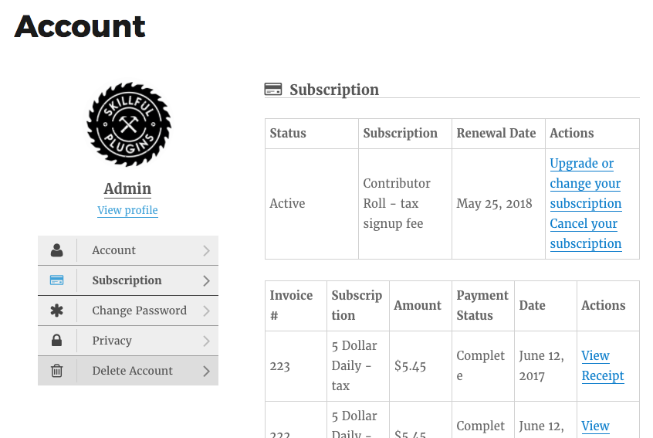

UM and WooCommerce

<https://docs.ultimatemember.com/article/1493-how-to-change-user-role-after-subscription>

## Secure dialog for Admin

In WordPress we had an issue with basic authentication dialog not working for /wp-admin/index.php.

We tried to solve this issue with NGINX configuration, but had no success.

In the end we changed all redirects from /wp-admin/index.php to just /wp-admin.

Redirect Admin users to /wp-admin so there is a basic authentication dialog box prompts for additional username and password?

[Oct 12, 2020 from Dima]

|  |
| --- |
| //---------------------------------------------------------------------------  // Redirect /wp-admin/index.php -> /wp-admin/  //---------------------------------------------------------------------------  add\_action( 'admin\_init', 'redirect\_index\_to\_wp\_admin' );  function redirect\_index\_to\_wp\_admin() {  if(strpos($\_SERVER['REQUEST\_URI'], '/wp-admin/index.php') !== false) {  wp\_redirect( admin\_url() );  exit;  }  } |

### Search Results

This page lists the relevant results according to the search query.

[Tech Note: It will use standard WP functionality and does search in all objects which WP indexes.]

This page may look like this (included into the Main template):

* **No results found**:

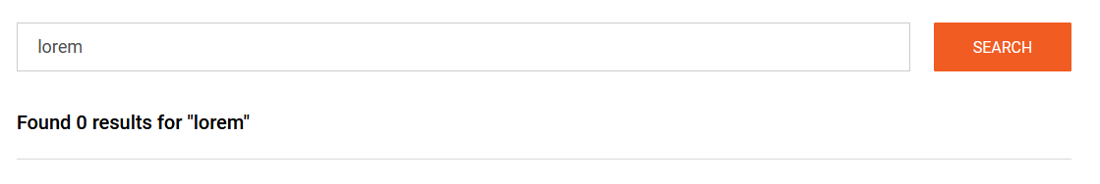

* **Some results found**:

|  |
| --- |
|  |

Controls description:

* 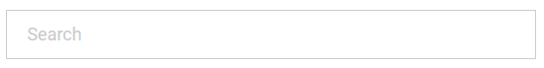 - search box. It’s a single-line textbox. Max length 300 chars. Placeholder ‘Search’
  + [NEXT VERSION: add auto-completion feature]
* Search button. It returns search results based on standard WP algorithms.
  + Searched text should remain in the textbox for quick correction.
* Section ‘Results’.
  + If no results found, then see how page should look like above in ‘**No results found**’.
  + If some results found, then page may look like above in ‘**Some results found**’.
    - List of results.
      * Most relevant results at the top [Tech Note: it should be done by WP, no extra coding required];
      * Title. This is a page, forum, article and other custom post titles; [Dev Note: In what objects WP can do search?].
        + This is a link on the found object in the same window;
      * Short fragment. [Tech Note: it should be done by WP, no extra coding required].
        + [Dev Note: does WP highlight searched phrase in the content? If NO – is it easy to implement?].
    - Page navigation. [Tech Note: use standard WP page navigation. Display 10 items per page].

## Video Hosting Service

[Open Issue to Angelina:

* What next steps. We recommend to buy Vimeo – Business Plan]

[Oct 30, 2020 from Andrei Stepasuk]

|  |
| --- |
| 1. Question about ability to track percent of video viewed progress.  In accordance with Vimeo documentation this option is available after Google Analytics integration in Business and Premium plans - https://vimeo.zendesk.com/hc/en-us/articles/224980588-Integrating-with-Google-Analytics  Also (as I understood for cheaper plans) there is article how to write custom code, that allows you to track video progress - <https://www.urbaninsight.com/article/tracking-progress-embedded-vimeo-videos>  2. About a way of embedding video on the page. In accordance with their Player SDK you have different ways:  a) To embed video with iframe tag, but you have full control on a player.  b) to embed video with any other HTML tag and also have full control on a player.  Examples - <https://developer.vimeo.com/player/sdk/basics>  3. About Wordpress plugins. There are several Vimeo Wordpress plugins, that allows to create galleries with Vimeo videos or show them in modal window or list of videos in a slider. But I think they are not useful for your goal.  <https://vimeo.com/upgrade> |

## Set/Reset Like Status

[PM: Nov 19, 2020: LIKE feature. Describe in spec how it should look like for logged in/ not logged in/the same user, what is orange and not]

Users can set and/or reset Like status by clicking LIKE icon anytime.

Icons below are for illustration only:

* Set LIKE:
  + Click C:\Users\Sergey\AppData\Local\Temp\snap_screen_20180207004714.png to LIKE an item.
    - Icon changes on new one C:\Users\Sergey\AppData\Local\Temp\snap_screen_20180207004529.png and increases stats
* Reset LIKE
  + Click C:\Users\Sergey\AppData\Local\Temp\snap_screen_20180207004529.png to reset LIKE.
    - Icon changes on this one C:\Users\Sergey\AppData\Local\Temp\snap_screen_20180207004714.png and decreases stats
* This icon should NOT be clickable for members who created this object (post, response and so on…). In other case they will LIKE their own objects.

## Date/Time format for Comments

Comments will use simplified date/time format.

[Tech Note: Note: date/time must be re-calculated and displayed in user local date/time, because date/time in DB is in GMT]

Date/Time format. Note: [Time Ago] = [Current Date/Time] - [Date/Time]

* If [Time Ago] < 24hr, then <time>. Example: ‘3:12’.
* If 24hr <= [Time Ago] < 48hr, then ‘yesterday’.
* Else - <date>. Example: Dec 01, 2020.

## List of Comments

[PM: No 19, 2020 Describe how to add points for LIKEs and Comments in spec]

List of comment displays comments from Old to New.

* New at the top, Old at the bottom.

This section may look like this (for illustration only):

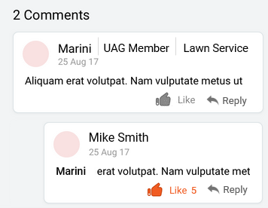

‘<N> Comments’:

* if there 1 comment the display 'Comments'
* if there are > 1 comments then display '<N> Comments'

Comment description:

* User avatar or placeholder if there is no avatar;
* Display Name;
* <user role>. If user role is UAG then ‘*UAG member*’, else – do not display role;
* <user Business Name>. If user has a Business Name then display it, else – do not display;
* Date/time when comment was posted. See [Date/time format for comments](#_Date/Time_format_for_1).
* Comment;
  + There are 2 levels only
    - All replies are displayed like the 2nd level, even if user replied on a reply
    - Example:

|  |
| --- |
| Comment 1  Reply 1.1 on comment 1  Reply 1.2 on comment 1  Reply 1.3 on reply 1.2  Comment 2  Reply 2.1 on comment 2  Reply 2.2 on reply 2.1  Reply 2.3 on reply 2.2  Comment 3  Comment 4  … |

* + If text includes words which begins with ‘www.’, ‘http://’ or ‘https://’ then they should look like links and be clickable to open an external browser. Links should look like links: echo brand orange color and underlined.
  + If this is a REPLY, then <username> to whom it was replied, should be displayed before the comment, see example:

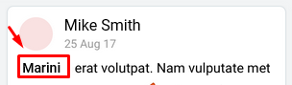

*  - Like action.
  + Disabled if 1) user is not logged in or 2) user is logged in and this comment belongs to this user (cannot like own comments).
  + SET / NOT SET icon status described in the [chapter ‘Set/Reset Like Status’](#_Set/Reset_Like_Status).
*  - Reply action
  + Disabled if 1) user is not logged in;
  + Clicking this icon opens the comment section.

List of comments is Empty if there are no comments.

## Points

Points are awarded to all user roles, but only [eligible users](#_Section_‘Get_to) are displayed in the Leaderboard.

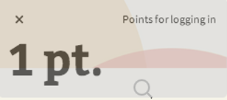 - This pop-up notification about getting X point(s) user will see at the top right or bottom corner.

Table with points:

[PM: add points for new features such as offers, school and networking]

[PM: review points for new activities and new table from Angelina

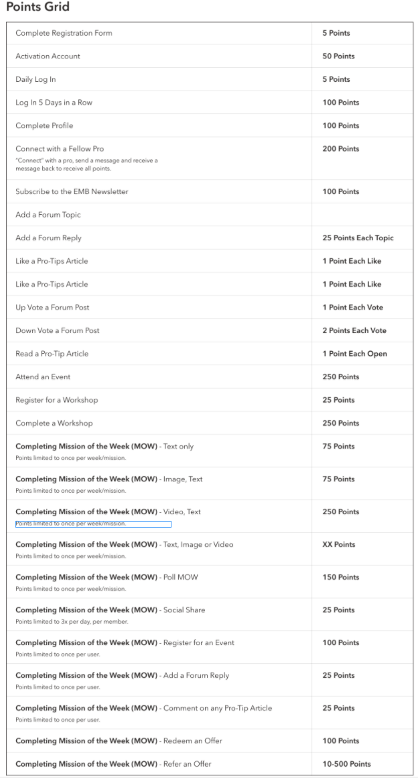]

Existing points:

|  |  |
| --- | --- |
| **Actions** | **Points**  **Earned** |
| *REGISTER ON WEBSITE*   * **Register on “ECHO MEANS BUSINESS” site**   **Notification:**  *‘<X> points - enrolling to site’* | 5 |
| *POST A QUESTION IN FORUM*  **Start a new conversation thread in the “Pro User Forum”**  Rules:   * 2 ballots per conversation thread * Maximum 10 points per day.   **Notification:**  *‘<X> points – posting a question in forum’* | 2 |
| *RESPOND TO POSTS IN FORUM*  **Respond to a conversation started by others in the “Pro User Forum”**  Ballots rules:   * 2 ballots per comment per conversation thread. If they post 10 times in one thread they only get 2 ballots. * Maximum 10 points per day.   **Notification:**  *‘<X> points – responding to posts in forum’* | 2 |
| *SHARE WEBSITE OR ARTICLE ON SOCIAL MEDIA (social media share buttons)*  Share:   * FB, Twitter, Google+, LinkedIn, Instagram   Ballot rules:   * 2 ballots per article shared. * If it’s easy, we can do 1 per network shared (so they click Share on FB and Share on Twitter, they get 4 ballots * Maximum 12 ballots per day [Sam: if it is quite complicated then move it into the Phase 2]. User still can share articles/pages but ballots will not be calculated   **Notification:**  *‘<X> points – sharing on social media’* | 2 |
| *COMPLETE ONLINE POLL*  This is poll on the home page  **Notification:**  *‘<X> points – completing a poll’* | 1 |
| [Jan 22, 2020. Added for new job]  NOTE: I decided do not include clicks on SHARE buttons, because it is difficult to track such clicks and check if it was actual shared or not | |
| WEBSITE. LOG IN or AUTO-LOGIN  Rule:   * Max 1 point per day * Record this point when user log in or auto-log in via website * It adds point independent from Mobile app log in actions   **Notification:**  *‘<X> points – logging to site’* | 1 |
| MOBILE APP. LOG IN or AUTO-LOGIN  [Tech Note: develop separate API for mobile app to call action when Login/Auto-Login occurs]  [Tech Note: save login date from mobile app in a separate field in database, separate from last login date from website]  Rule:   * Max 1 point per day * Record this point when user log in or auto-log in via mobile app * It adds point independent from Website log in actions | 1 |
|  |  |
| MOBILE APP. CHALLENGE. ADD **RESPONSE**  Rule:   * No Max points limitations, because user can post only one response per one challenge | 3 |
| MOBILE APP. CHALLENGE **RESPONSE**. LIKE RESPONSE  Rule:   * 1 point per response. It means that even if user liked, then disliked, then liked again and so on – system should count only 1 point for this particular response.   + Even if user likes response today and dislikes and likes it again the next day – system will assign 1 point the day when he first time liked the response * Max 3 points per day. If user likes 3 different responses.   [Tech Note: Dislike will not deduct points. Technically it is quite complicated. I decided do not code this feature] | 1 |
| MOBILE APP. CHALLENGE **RESPONSE**. ADD COMMENT or REPLY TO COMMENT  Rule:   * 2 points per response per day. It means that even if user adds 2 (or more) separate comments inside one response the same day – system should count only 2 points for this particular response.   + Example:     - Today user added 3 comments for response #1 and 2 comments for response #2 - system adds 4 points this day:       * 2 points for response #1       * and 2 points for response #2.     - Next day this user adds 4 comments for the response #1 – system adds 2 points for this day. * Max 10 points per day. If user comments in 5 different responses. | 2 |
| MOBILE APP. CHALLENGE **RESPONSE**. LIKE COMMENT  Rule:   * 1 point per response per day. It means that even if user liked, then disliked the same comment or different comments inside the same response the same day – system should count only 1 point for this particular response within this day.   + Example:     - User likes 5 comments in response #1 and 3 comments in response #2 this day – system adds 2 points: 1 point for response #1 and 1 point for response #2.     - The next day user likes other comments or (dislikes and likes again the same comment) in response #1 – system add 1 point that day * Max 3 points per day. If user likes comments in 3 different responses.   [Tech Note: Dislike will not deduct points. Technically it is quite complicated. I decided do not code this feature] | 1 |
|  |  |
| MOBILE APP. ADD **POST**  Rule:   * Max 9 points per day. Means only first 3 posts per day will give user points | 3 |
| MOBILE APP. **POST**. LIKE POST  Rule:   * The same as for ‘***CHALLENGE RESPONSE. LIKE RESPONSE***’ | 1 |
| MOBILE APP. **POST**. ADD COMMENT or REPLY TO COMMENT  Rule:   * The same as for ‘***CHALLENGE RESPONSE. ADD COMMENT or REPLY TO COMMENT***’ | 2 |
| MOBILE APP. **POST**. LIKE COMMENT  Rule:   * The same as for ‘***CHALLENGE RESPONSE. LIKE COMMENT’*** | 1 |
|  |  |
| MOBILE APP. **ARTICLE**. LIKE ARTICLE  Rule:   * The same as for ‘***CHALLENGE RESPONSE. LIKE RESPONSE***’ | 1 |
| MOBILE APP. **ARTICLE**. ADD COMMENT or REPLY TO COMMENT  Rule:   * The same as for ‘***CHALLENGE RESPONSE. ADD COMMENT or REPLY TO COMMENT***’ | 2 |
| MOBILE APP. **ARTICLE**. LIKE COMMENT  Rule:   * The same as for ‘***CHALLENGE RESPONSE. LIKE COMMENT’*** | 1 |

## Badges

Badges may look like this (for illustration only):

* All images are located in Project Drive here:  
  <https://drive.google.com/drive/u/0/folders/1JDvzkOtmbx14S066xhJ723riQXYY6D7c>

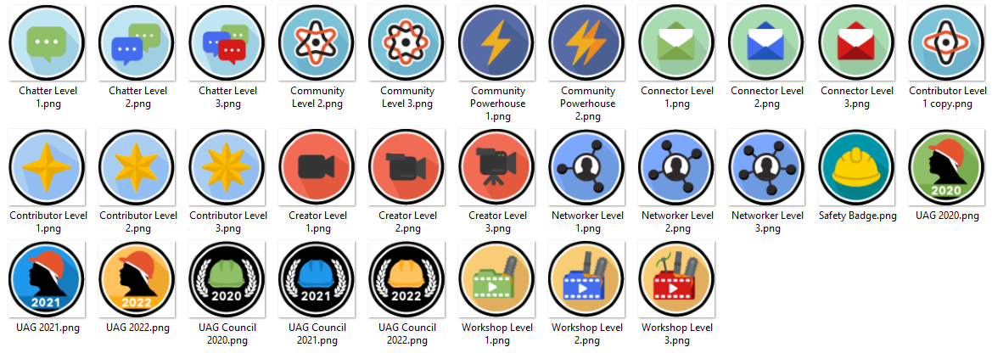

[PM: review all items and add questions. Not sure that we can implement all of them in Phase 1]

Rules:

* All rules are described here: <https://docs.google.com/spreadsheets/d/1nBFBaD2FtEHmWyJ3Zm5aMI1fgdKMMPkUK4o4SHdR69E/edit#gid=1653892273>

|  |  |
| --- | --- |
| **BADGE NAME** | **DESCRIPTION** |
| UAG Council 2020 | Badge given retroactively to UAG Council members in 2020 (only those who stayed with program) |
| UAG Council 2021 | Badge given to UAG Council members in 2021 |
| UAG Council 2022 | Badge given to UAG Council members in 2022 (etc) |
| UAG 2020 | Badge awarded retroactively to UAG members in 2020 |
| UAG 2021 | Badge given to 2021 UAG members |
| UAG 2022 | Badge given to 2022 UAG members (etc) |
| Contributor Level 1 | Badge awarded for non-UAG members who have 1 post published on site |
| Contributor Level 2 | Badge awarded for non-UAG members who have 5 or more posts published to site |
| Contributor Level 3 | Badge awarded for non-UAG members who have 15 or more posts published to site |
| Creator Level 1 | UAG Member who has 5 posts uploaded to site |
| Creator Level 2 | UAG Member who has 15 posts published to site |
| Creator Level 3 | UAG Membrer who has 25 posts published to site |
| Connector Level 1 | Messages and connects with 5 pros |
| Connector Level 2 | Messages and connects with 25 pros |
| Connector Level 3 | Messages and connects with 100 pros |
| Community Level 1 | Enrolls as a basic or paid member |
| Community Level 2 | Logs in 5 consecutive days |
| Community Level 3 | Logs in 20 times in one month |
| Chatter Level 1 | Posts a comment in 5 Forum conversations |
| Chatter Level 2 | Posts a comment in 25 Forum conversations |
| Chatter Level 3 | Posts a comment in 100 Forum conversations |
| Networker Level 1 | Participates in 1 newtorking event |
| Networker Level 2 | Participates in 3 networking events |
| Networker Level 3 | Participates in 7 newtorking events |
| Workshop Level 1 | Completes one workshop video |
| Workshop Level 2 | Completes 5 workshop videos |
| Workshop Level 3 | Completes 10 workshop videos |
| Safety Badge | Downloads or opens 5 NALP safety documents (PDFs) available on site |
| Community Powerhouse 1 | Earned Contibutor Level 1, Connector Level 1, Networker Level 1, and Community Level 1 Badges |
| Community Powerhouse 2 | Earned Contibutor Level 2, Connector Level 2, Networker Level 2, and Community Level 2 Badges |

## UltimateMember Settings

This section describes settings for UltimateMember plugin

### Email

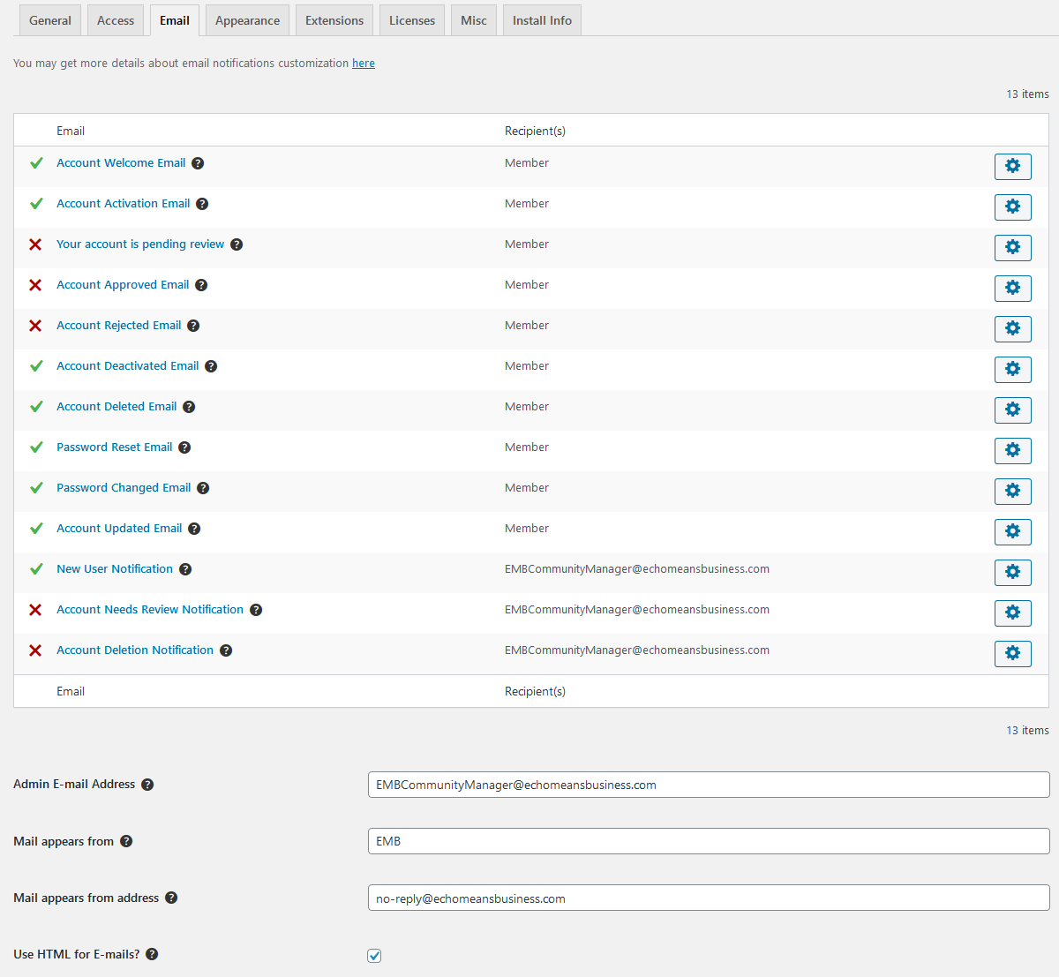

### Registration Form

Settings:

* Do not request strong password
* Do not add confirm password field

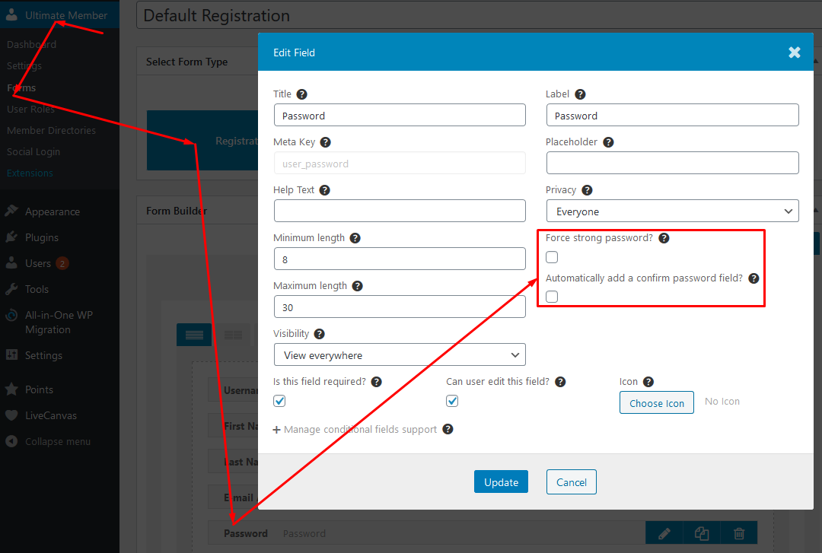

### User Roles

These settings require people to confirm their registration and automatically log in after confirmation.

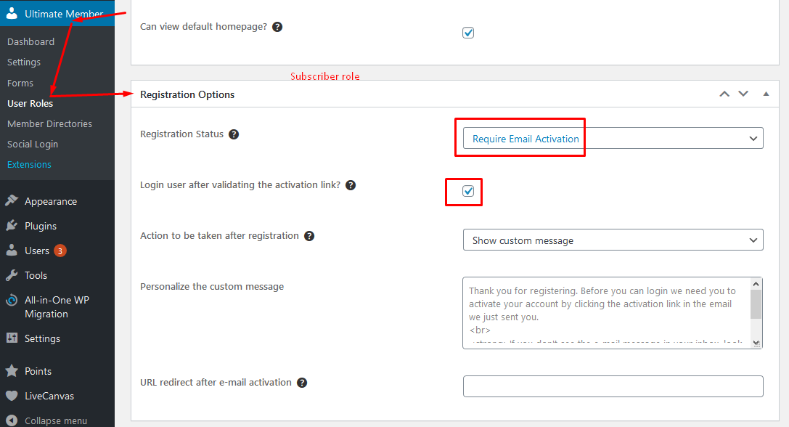

### Account Tab

Do not display Account tab inside My Account section for logged in user

